

DG MARKT
Framework Contract No DI/6769-2
Specific Contract No 4708

Digital Signature Services Post-Implementation
Technical Analysis
Design Model


ARHS Logo

Subject | Design Model
Version | 2.00
Release Date | 20/01/2012
Filename | 0000.doc
Document Reference | DSS2-DM

Document History

Document History
Version | Deliverable | Release Date | Author | Description
0.01 | DLV 1.3 | 11/03/2011 | Christian Hiedels,  David Naramski | Version sent for Review
0.02 | DLV 1.3 | 19/04/2011 | David Naramski | Version sent for Acceptance
0.90 | DLV 3.3 | 30/06/2011 | Christian Hiedels, David Naramski | Version sent for Review
1.00 | DLV 3.3 | 27/07/2011 | Christian Hiedels | Version sent for Acceptance
1.01 | DLV 3.3 | 06/01/2012 | David Naramski | Version sent for Review  Added ASiC-S details (section 4.4)
2.00 | DLV 3.3 | 20/01/2012 | David Naramski | Version sent for Acceptance

Reviews
Version | Release Date | Reviewer | Position
0.01 | 11/03/2011 | Frank Meyer | Project Manager
0.02 | 19/04/2011 | Frank Meyer | Project Manager
0.90 | 30/06/2011 | Frank Meyer | Project Manager
1.00 | 27/07/2011 | Frank Meyer | Project Manager
1.01 | 06/01/2012 | Frank Meyer | Project Manager
2.00 | 20/01/2012 | Frank Meyer | Project Manager

Table Of Contents

1 Introduction 9
1.1 Purpose of the Document 9
1.2 Scope of the Document 9
1.3 Intended Audience 9
1.4 Structure of the Document 9
2 DSS Components 11
2.1 Components covered by this document 13
3 Signing with Java 14
3.1 Signing with Java in the classic way 14
3.2 Signing with Java and a Smartcard 15
4 Detailed profile for AdES 16
4.1 XAdES 16
4.1.1 XAdES-BES 16
4.1.2 XAdES-EPES 16
4.1.3 XAdES-T 17
4.1.4 XAdES-C 17
4.1.5 XAdES-X 17
4.1.6 XAdES-X-L 17
4.1.7 XAdES-A 17
4.2 CAdES 17
4.2.1 CAdES-BES 17
4.2.2 CAdES-EPES 18
4.2.3 CAdES-T 18
4.2.4 CAdES-C 18
4.2.5 CAdES-X 18
4.2.6 CAdES-X-L 18
4.2.7 CAdES-A 18
4.3 PAdES 19
4.3.1 PAdES-BES 19
4.3.2 PAdES-EPES 19
4.3.3 PAdES-LTV 19
4.4 ASiC-S 19
5 Signing Devices 20
5.1 Signature Tokens 20
5.2 Signatures in the Applet 21
5.3 Communication with the Signing Applet 22
6 Document Signer Service 24
6.1 Integration of other Document Signature Format 24
6.2 Extending a signature 25
7 Verification and Validation 26
7.1 Signature Verification 26
7.2 Certificate Validation 26
7.2.1 CertificateSource 26
7.2.2 CRLSource and OCSPSource 27
7.2.3 Validation algorithm for a Certificate 29
8 PDF Signature 32
8.1 iText 33
9 WebServices 34
9.1 Signature Service 34
9.2 Validation Service 36
10 TLManager 40
10.1 Presentation Layer 41
10.1.1 Binding 43
10.1.2 Additional components 44
10.1.3 DateTimePicker 46
10.1.4 Certificate Viewer 47
10.2 Business Layer 48
10.2.1 Layer Interaction 48
10.2.2 Object prefilling 49
10.2.3 Validation and Signing 50
10.3 Persistence Layer 52
10.4 CONFIGURATION FILE 54
11 Appendix I: How to use Java PC/SC 55
12 Appendix II: Reuse FEDICT eID component 59
13 Appendix III: Validation report structure 60
13.1 Introduction 60
13.1.1 Used type 60
13.2 Validation report 61
13.2.1 Time information 61
13.2.2 Signature information 61

List of Tables

Table 1: Reference Documents 7
Table 2: Applicable Documents 7
Table 3: Abbreviations and Acronyms 8

List of Figures

Figure 1: DSS’s Project Components 11
Figure 2: DSS topic roadmap 13
Figure 3: Three implementations of the signature API 21
Figure 4: Protocol sequence diagram 22
Figure 5: Communication Layer of the applet 23
Figure 6: Implementation of DocumentSignatureService 24
Figure 7: CertificateSource 27
Figure 8: CRLSource 28
Figure 9: OCSPSource 28
Figure 10: Signature Service WSDL contract 36
Figure 11: Validation Service WSDL contract 39
Figure 12: Layers of TLManager 40
Figure 13: MainFrame and content pages 41
Figure 14: TreeDataPublisher and a content page 42
Figure 15: The BindingManager 43
Figure 16: Example of a MultivalueDialog for Multilingual values and PostalContent 44
Figure 17: Multivalue classes with two exemplary content implementations 45
Figure 18: DateTimePicker 47
Figure 19: Certificate Viewer without data 47
Figure 20: Interaction between the layers 49
Figure 21: ObjectFiller class 50
Figure 22: Validation class 51
Figure 23: Sample of classes generated by JAXB 53
Figure 24: Implementations of a TSL 54
Figure 25: Implementation of SignatureTokenConnection for Java 6 IO PC/SC 55
Figure 26: DSSDocumentService Class Diagram 59

Reference and Applicable Documents
This section contains the lists of all reference and applicable documents. When referring to any of the documents below, the bracketed reference will be used in the text, such as [R01].

Reference Documents
Ref. | Title | Reference | Version | Date
R01 | DSS Software Architecture Document | DSS2-SAD | 1.01 | 04/01/2012
R02 | eID-Applet | http://eid-applet.googlecode.com/svn/!svn/bc/502/trunk/ | 502 | N/A
R03 | Santuario | http://santuario.apache.org/Java/index.html | 1.4.4 | N/A
R04 | BouncyCastle | http://www.bouncycastle.org/java.html | 1.45 | N/A
R05 | iText | http://sourceforge.net/projects/itext/ | 2.1.7 | N/A
R06 | SwingX | http://java.net/projects/swingx | 1.6.1 | N/A
R07 | JavaTM Cryptography Architecture | http://download.oracle.com/javase/6/docs/technotes/guides/security/crypto/CryptoSpec.html | 1.6 | N/A
R08 | Trusted List Specification | ETSI TS 102 231 | 3.1.2 | 12/2009
R09 | DSS Functional Analysis Document | DSS2-FAD | 1.01 | 04/01/2012
R10 | CD 2009-767-EC corrigendum | 2009/767/EC | N/A | 14/11/2009
R11 | CD 2011-130-EU | http://eur-lex.europa.eu/JOHtml.do?uri=OJ:L:2011:053:SOM:EN:HTML | N/A | 26/02/2011
R12 | CD 2010-425-EU | 2010/425/EU | N/A | 30/07/2010
Table 1: Reference Documents

Applicable Documents
Ref. | Title | Reference | Version | Date
A01 | Framework Contract ESP DESIS II – Lot 2 | DI/6769-2 | N/A | 25/02/2011
A02 | Specific Contract | SC 4708 | N/A | 10/10/2011
A03 | “Quoted Time & Means” Form # 3 | QTM-T3 | N/A | 21/10/2011
Table 2: Applicable Documents

Abbreviations and Acronyms

Abbreviations and Acronyms
Abbreviation | Meaning
AdES | Advanced Electronic Signature
API | Application Programming Interface
CAdES | CMS Advanced Electronic Signatures
CRL | Certificate Revocation List
DSS | Digital Signature Service
EJB | Enterprise Java Beans
ETSI | European Telecommunications Standards Institute
EUPL | European Union Public License
FSF | Free Software Foundation
GUI | Graphical User Interface
I18N | Internationalisation
JAXB | Java Architecture for XML Binding
JCA | Java Cryptographic Architecture
JCE | Java Cryptography Extension
Java EE | Java Enterprise Edition
LGPL | Lesser General Public License
LOTL | List of Trusted List
MIT | Massachusetts Institute of Technology
OCSP | On-Line Certificate Status Protocol
ODT | Open Document Text
OOXML | Office Open XML
OSI | Open Source Initiative
OSS | Open Source Software
PAdES | PDF Advanced Electronic Signatures
PKIX | Internet X.509 Public Key Infrastructure
SAD | Software Architecture Document
SOA | Service Oriented Architecture
SOAP | Simple Object Access Protocol
TL | Trusted List
WSDL | Web Services Description Language
WYSIWYS | What you see is what you sign
XAdES | XML Advanced Electronic Signatures
Table 3: Abbreviations and Acronyms

Introduction

Purpose of the Document
The Design Model Document is part of the technical specification. It is an abstraction of the application’s implementation. This document describes how the functional analysis is translated and structured in the architecture by the development team.

Scope of the Document
This document is part of the Technical Analysis and it details the necessary technologies to represent the software design.

Intended Audience
The present document is intended to be read by the following teams, but not limited to:
- DG MARKT Team;
- Development Teams.

Structure of the Document
The document is organised as follows:
- Chapter 1 - Introduction summarises the purpose and scope of the document and the intended audience.
- Chapter 2 - DSS Components describes the main components of the DSS project.
- Chapter 3 - Signing with Java describes how the signature technology can be used in Java.
- Chapter 4 - Detailed profile for AdES details the advanced signature profile supported by DSS.
- Chapter 5 - Signing Devices contains information about how communication is established with signing devices, as well as digests are signed.
- Chapter 6 - Document Signer Service describes how documents are signed.
- Chapter 7 - Verification and Validation explains how signatures are verified.
- Chapter 8 - PDF Signature illustrates briefly what a PDF Signature is.
- Chapter 9 - WebServices describes the functionalitites of DSS that will be exposed through SOAP web services.
- Chapter 10 - TLManager describes how the construction of the TLManager software will be achieved using Swing.
- Chapter 11 - Appendix I: How to use Java PC/SC details an example of PC/SC implementation for Belgian ID card.
- Chapter 12 - Appendix II: Reuse FEDICT eID component describes briefly how to add support for other file format, reusing component from FEDICT eID tool.
- Chapter 13 - Appendix III: Validation report structure details the validation report produced by the DSS/Web.

DSS Components
As described in the Software Architecture Document (cf. [R01]), the DSS project will deliver two software products that share some components:
- TLManager application will permit to create and edit and sign Trusted Lists (TL) for Member States, as well as List of Trusted Lists (LOTL).
- DSS/Web application will provide the functionality to create e-signatures and apply them to documents of XML, Binary or PDF file format, as well as to verify and/or extend a received signature.
The basic components in DSS handled in this document are shown below:
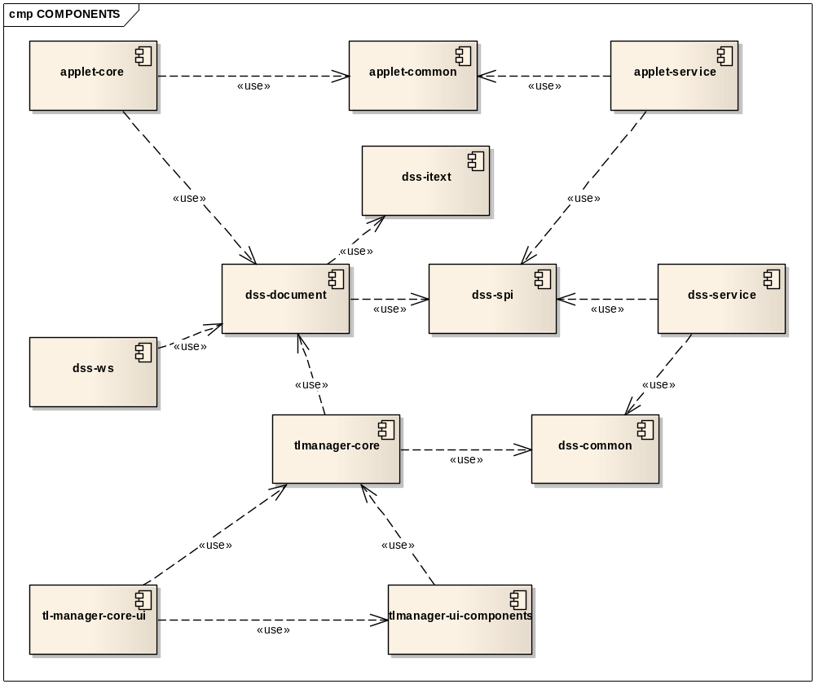
Figure 1: DSS’s Project Components

Component | Description
applet-common | Contains the DTO objects used to exchange informations between applet-core (client-side) and applet-service (server-side).
applet-core | Applet that contains communication details with SSCD. Some of the communication details are presented in section “5 - Signing Devices”. Furthermore it contains the capability for validation of signatures.
applet-service | The applet-service is the endpoint (server-side) used by applet-core to communicate with the backend server.
dss-common | The two main components of DSS are TLManager and DSS/Web. These two components are using the TSLs. This dss-common module contains the logic needed to parse and create TSLs file-format. The technology used (JAXB) is discussed in section “10.3 - Persistence Layer”.
dss-document | Contains the signature methods for XML, PDF, binary (CMS) and ASiC. The creation of a Document Signer is explained in section “6 - Document Signer Service”.
dss-itext | Library for PDF manipulation. Some details of the PDF signature format is briefly explained in section “8 - PDF Signature”.
dss-service | Server-side implementation of DSS/Web.
dss-spi | Service Provider Interface of DSS/Web.
dss-ws | SOAP web service implementation of DSS/Web services. This SOAP endpoint permits the use of DSS/Web functionality from a third party application.
tlmanager-core | Core classes of TLManager for covering signature and validation tasks. Pre-filling of JAXB-Objects is also covered here.
tlmanager-ui | All view logic for TLManager including binding and signature wizard.
tlmanager-ui-components | Additional view components for TLManager.

Components covered by this document
This document details technical aspects of the whole DSS project. Each section covers a specific aspect of the project, like communication, detailed architecture etc.
The diagram below shows which topic is explained in which section:
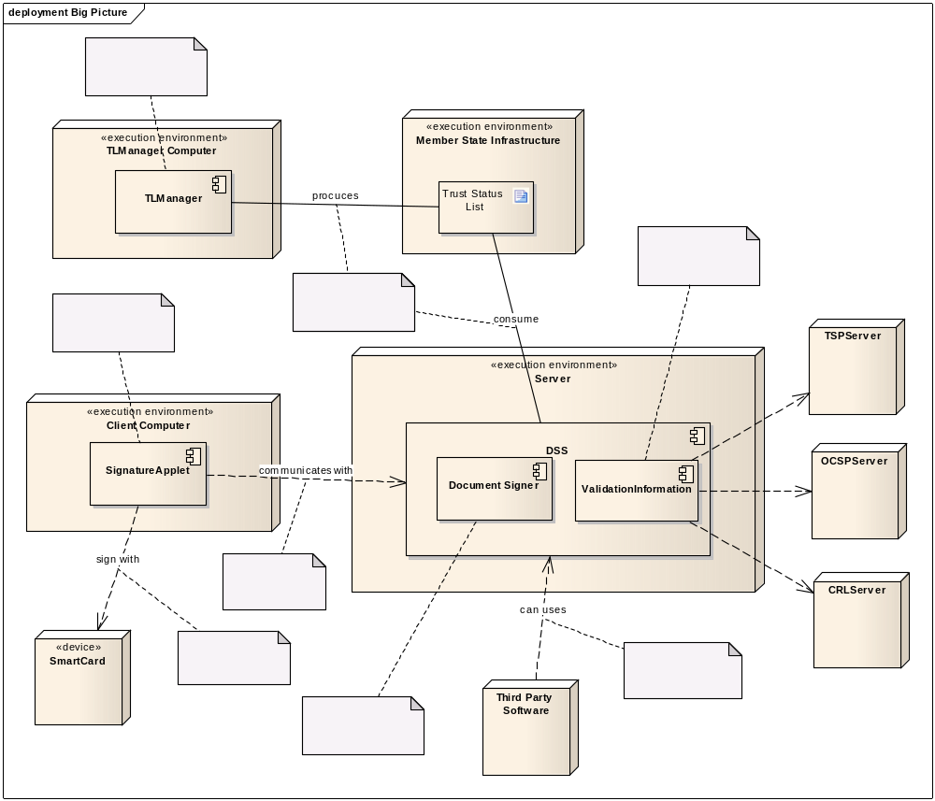
Section 5.3
Section 5.1
Section 10
Section 5.2
Section 10.3
Section 7
Section 6
Section 9
Figure 2: DSS topic roadmap

Signing with Java
The Java environment proposes a complete API for signature creation and verification. Project DSS will make use of all the aspects proposed by this API.

Signing with Java in the classic way
As described in [R07], a simple signature in Java can be achieved by the following source code:
KeyStore ks = KeyStore.getInstance("JKS");
ks.load(new FileInputStream("src/test/resources/dummy_ks.jks"), "password".toCharArray());
String alias = (String) ks.aliases().nextElement();
PrivateKey key = (PrivateKey) ks.getKey(alias, "password".toCharArray());

Signature sig = Signature.getInstance("SHA1withRSA");
sig.initSign(key);
sig.update("Hello World".getBytes());

byte[] signatureValue = sig.sign();
This produces a signature that is composed by the encryption (with RSA) of the hash (SHA1) of the data “Hello World”.
The signature object is performing the following steps:
- Creating a digester with the SHA1 algorithm.
- Compute digest value from the data “Hello World”.
- Wrap the digest in a byte array.
- Encrypt the digest with the private key (so it will be possible to decrypt the value later with the public key).

This signature can be verified by the following source code:
KeyStore ks = KeyStore.getInstance("JKS");
ks.load(new FileInputStream("src/test/resources/dummy_ks.jks"), "password".toCharArray());
String alias = (String) ks.aliases().nextElement();

Signature sig = Signature.getInstance("SHA1withRSA");
sig.initVerify(ks.getCertificate(alias));
sig.update("Hello World".getBytes());

byte[] signatureValue = retrieved signature value (see above)
boolean valid = sig.verify(signatureValue);
The verification uses only the publicly available certificate.
The signature object is performing the following steps:
- Creating a digester with the SHA1 algorithm.
- Compute digest value from data “Hello World”, because the signature contains only the encrypted digest and not the original data. In order to verify a signature, the original data needs to be digested again.
- Decrypt the signatureValue with the public key and unwrap the other digest. The signature contains the encrypted digest (with the signer private key) so it can be decrypted using the public key of the signer and compare both digests for equality. This is done by the ‘sig.verify’ call.

Signing with Java and a Smartcard
When the digest of a block of data shall be signed instead of the data itself, a Smartcard can be used.
The following code produces the same signature as in the chapter above:
MessageDigest digest = MessageDigest.getInstance("SHA1");
byte[] digestValue = digest.digest("Hello World".getBytes());

Cipher cipher = Cipher.getInstance("RSA/ECB/PKCS1Padding");
cipher.init(Cipher.ENCRYPT_MODE, key);

/* Wrap info and DIGEST */
byte[] SHA1_DIGEST_INFO_PREFIX = new byte[] { 0x30, 0x1f, 0x30, 0x07, 0x06, 0x05, 0x2b, 0x0e, 0x03, 0x02, 0x1a, 0x04, 0x14 };
byte[] container = new byte[SHA1_DIGEST_INFO_PREFIX.length + digestValue.length];
int i = 0;
for (byte b : SHA1_DIGEST_INFO_PREFIX) { container[i++] = b; }
for (byte b : digestValue) { container[i++] = b; }

byte[] signatureValue = cipher.doFinal(container);

By using this code, the digest of a document can be signed independently from the document.
Previously the steps were:
- Creating a digester with the SHA1 algorithm.
- Compute digest value from the data “Hello World”.
- Wrap the digest in a byte array.
- Encrypt the digest with the private key (so it will be possible to decrypt the value later with the public key).
But the details were hidden by the Signature class. In the sample above, we follow the same steps, but in a more technical way.
- Digest: previously, the whole digest operation (step 1 and 2) was hidden by the sig.update call. Now it’s done explicitly with the MessageDigest object.
- Again, the wrapping of the digest in an ASN1 structure is explicit. Previously, it was hidden by the sig.sign. The wrapping is done by adding a prefix that describes what is contained in the byte array. In this case: a SHA1 digest.
- And finally, the encryption of the generated byte array with the private key is done using the Cipher object (in encryption mode).

Detailed profile for AdES
The DSS project will support XAdES, CAdES, PAdES and ASiC signature formats. This section describes the profiles that DSS will support. When creating, the values are restricted by the profile. The validation algorithm needs to be able to validate any type of conforming AdES signature.
The DSS-FAD2 [R09] describes the profiles for the conforming signature creation/validation tool, according to CD 2011-130-EU (cf. [R11]). This section will detail, from a technical point of view, which are the values that will be supported by DSS when it creates a signature.
When creating a signature, the minimal amount of data is used to specify a signature level and no special data will be introduced. This way it is ensured, that other software products don’t have to deal with anything besides the specification.
When validating a signature, it is important to take all alternatives in describing signature levels into account, to ensure that as many variations to signatures as possible can be understood. The validation process is described in the DSS-FAD2 [R09] document.

XAdES
The XAdES creation/validation follows CD 2011/130/EU (cf. [R11]). At the creation time the values are specified by the profile. At the validation time, every conforming signature must be supported.

XAdES-BES
Signature element | Profile
ds:CanonicalizationMethod | xml-c14n11
ds:SignatureMethod | RSA
ds:DigestMethod | xmlenc#sha256  xmldsig#sha1
ds:Transform | Enveloped signature transforms  Base64 encoding
ds:KeyInfo | X509Certificate
xades:SigningTime
xades:ClaimedRole | String value

XAdES-EPES

Signature element | Profile
xades:SignaturePolicyIdentifier | String value

XAdES-T
Signature element | Profile
xades:SignatureTimeStamp | Encapsuled timestamp

XAdES-C
Signature element | Profile
xades:CompleteCertificateRefs | CRLRefs  OCSPRefs

XAdES-X
Signature element | Profile
xades:SigAndRefsTimeStamp | Encapsuled timestamp

XAdES-X-L
Signature element | Profile
xades: CertificateValues | X509Certificate
Xades: RevocationValues | CRLValues  OCSPValues

XAdES-A
Signature element | Profile
xadesv141:ArchiveTimeStamp | Encapsuled timestamp

CAdES
The CAdES creation follows CD 2011/130/EU (cf. [R11]). At the creation time the values are specified by the profile. At the validation time, every conforming signature must be supported.

CAdES-BES
Signature element | Profile
Signature algorithm | RSA
id-messageDigest | sha256  sha1
id-ContentType
SignedData.certificates | ESS signing-certificate  ESS signing-certificate v2
claimedAttributes

CAdES-EPES
Signature element | Profile
sigPolicyId | String value

CAdES-T
Signature element | Profile
signature-time-stamp

CAdES-C
Signature element | Profile
complete-certificate-references
complete revocation status references | complete-revocation-references.crlids  complete-revocation-references.ocspids

CAdES-X
Signature element | Profile
xades:SigAndRefsTimeStamp | Encapsuled timestamp

CAdES-X-L
Signature element | Profile
xades: CertificateValues | X509Certificate
revocation status values | revocation-values.crlVals  revocation-values.ocspVals

CAdES-A
Signature element | Profile
xadesv141:ArchiveTimeStamp | Encapsuled timestamp

PAdES
The PAdES creation follows CD 2011/130/EU (cf. [R09]). At the creation time the values are specified by the profile. At the validation time, every conforming signature must be supported.

PAdES-BES
Signature element | Profile
Signature algorithm | RSA
id-messageDigest | sha1
id-ContentType
SignedData.certificates | ESS signing-certificate  ESS signing-certificate v2
claimedAttributes

PAdES-EPES
Signature element | Profile
sigPolicyId | String value

PAdES-LTV

Signature element | Profile
Additional dictionaries | VRI

ASiC-S
The ASiC-S creation follows DSS2-FAD (cf. [R11]). At the creation time the values are specified by the profile. At the validation time, every conforming signature must be supported. If the user wants to sign multiple files, it’s possible to gather them in an archive and sign the archive itself.
As described in DSS2-FAD [R11] section 5.4.7, the signature wrapped in the ASiC container will follow the XAdES profile. Therefore, the detailed profile of ASiC-S will be identical to 4.1 - XAdES.
As recommended by the specification:
- The file extension for ASiC-S will be “.asics”
- The file “mimetype” will contains “application/vnd.etsi.asic-s+zip”
- The signed data object and the mimetype file will be the only files at the package root level.
- The META-INF/signatures.xml will contains the XAdES signature

Signing Devices
The whole DSS project is about creating and validating signatures. The base of a signature is a digest, which gets signed with a private key. This chapter will detail how a basic signature can be created.

Signature Tokens
TLManager and DSS/Web are both able to create signatures from PKCS#11, PKCS#12 and MS CAPI APIs. Java 6 is inherently capable of communicating with these kinds of KeyStores.
TLManager is a Java desktop application and poses no problem for communicating directly with a SSCD that respects PKCS#11 or MS CAPI APIs.
DSS/Web is a web application that runs on a Java based Application Server, but the SSCD that provides the private key for a signature is located on a client’s machine. It will be accessed by an applet that runs in the browser of the clients. To overcome sandbox restrictions that would prevent it from using the SSCD hardware, the applet itself has to be signed though.
To be independent of the signing media, DSS components will use an interface named SignatureTokenConnection. The DSS project will provide three implementations of this interface:
- Pkcs11SignatureToken for PKCS#11 SSCD;
- Pkcs12SignatureToken for PKCS#12 files;
- MSCAPISignatureToken that use the Microsoft API.
This design permits other card providers/adopters to create own implementations. For example, this can be used for a direct connection to the Smartcard through Java 6 PC/SC.
DSS uses two types of SignatureTokenConnection. The base implementations are able to sign a stream of data. That means that all the data to be signed needs to be sent do the SignatureTokenConnection.
The PKCS#11 and PKCS#12 API gives to the developer a finer control in the signature operation. PKCS#11’s implementation should implements the AsyncSignatureTokenConnection that permits to execute the digest operation and signature operation in two different threads or even two different hardwares.
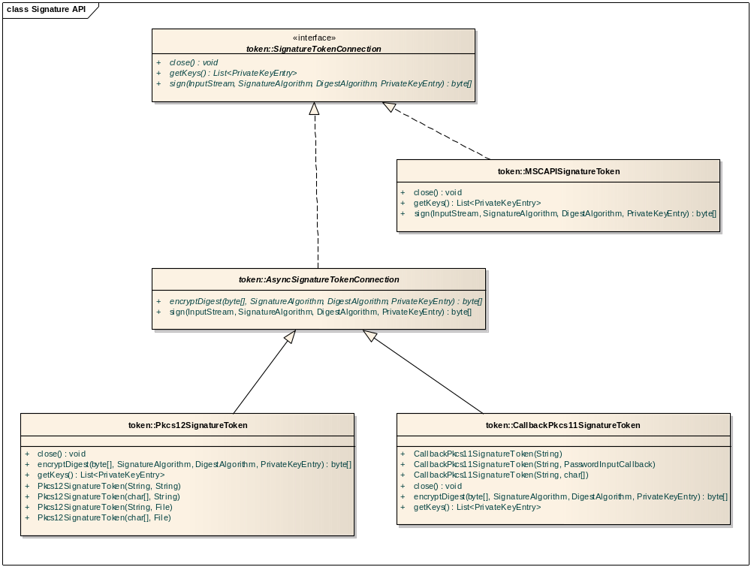
Figure 3: Three implementations of the signature API
A sample of how this can be extended to add a direct Java 6 Smartcard IO implementation for the Belgian ID Smartcard is given in “Appendix I: How to use Java PC/SC”.

Signatures in the Applet
As motivated in the DSS2-SAD (cf. [R01]), the applet of DSS/Web will be responsible for many tasks concerning electronic signatures (based on well isolated jars).
As a result, the DSS/Web server will be less involved once the applet was spawned in the browser of a client, which reduces the amount of data transferred over the network (e.g. documents are not transmitted back and forth) and the complexity of the protocol is mitigated (less messages).
As illustrated in Figure 1, the applet directly incorporates the XML, CMS, PDF and ASiC Document Signer. This approach enables it to calculate the digest of a document or insert a signature in a document without contacting the DSS/Web server at all.
Nevertheless, some operations can not be implemented by the applet: For validation purposes, it will be necessary to use HTTP connections to OCSP servers. Since such connections may not be endangered by manipulations or obstructed by connection issues, the DSS/Web server will perform these duties.
Basically two new messages will be introduced to allow an indirect questioning of TSP/OCSP servers for retrieving OCSP status information or TimeStampToken creation:
- TimeStampTokenRequestMessage;
- OCSPRequestMessage.
Their respective MessageHandlers will run on the DSS/Web Server and communicate with appropriate 3rd party servers:
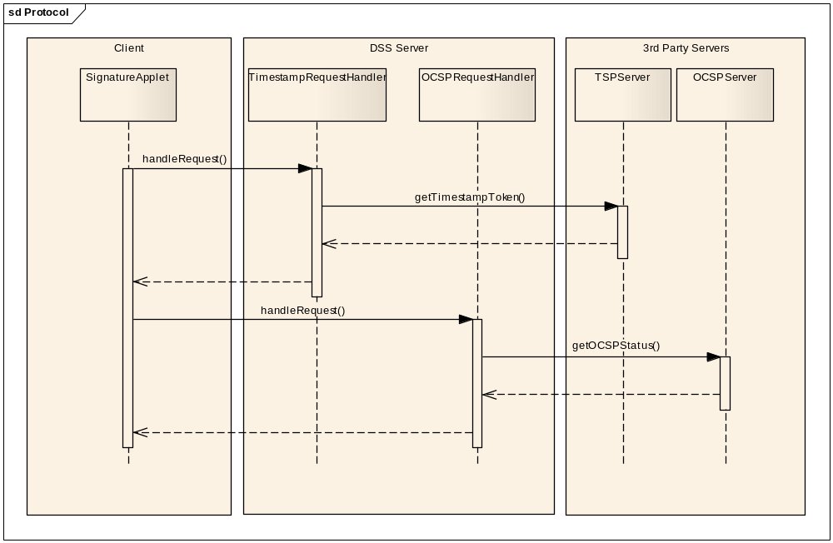
Figure 4: Protocol sequence diagram

Communication with the Signing Applet
The applet communicates with the web application via the module applet-service using HTTP(S). The role of this module is to deserialize the applet’s requests and send serialized responses back.
A Proxy design pattern is used. The applet use proxied CertificateSource, TSPSource, OCSPSource and CRLSource. All the requests to these sources results in a call to the back-end server. For each proxy, an AbstractServiceHandler is implemented.
The AppletServiceServlet uses an HttpReceiver and an Unmarshaller to deserialize the applet requests.Then the servlet transmits the call to the appropriate MessageHandler that is able to serve the request. The result from the MessageHandler is serialized and transmitted to the applet.
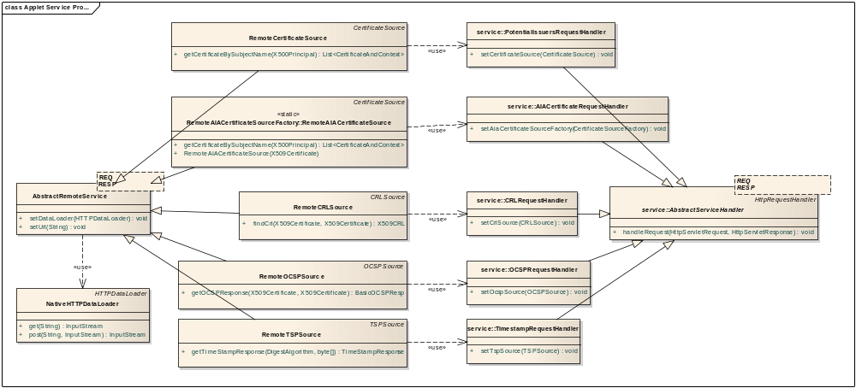
Figure 5: Communication Layer of the applet

The applet has the responsibility to sign a document and validate a signature of a document. For this, it needs OCSP responses and TSP timestamps. The applet will communicate with the DSS/Web server and requests OCSP and TSP values.

Document Signer Service
Each document format specific module implements the interface DocumentSignatureService. It abstracts all the details of handling a file format during the operations of e-signature. In order to introduce another file format, a specific implementation has to be created.
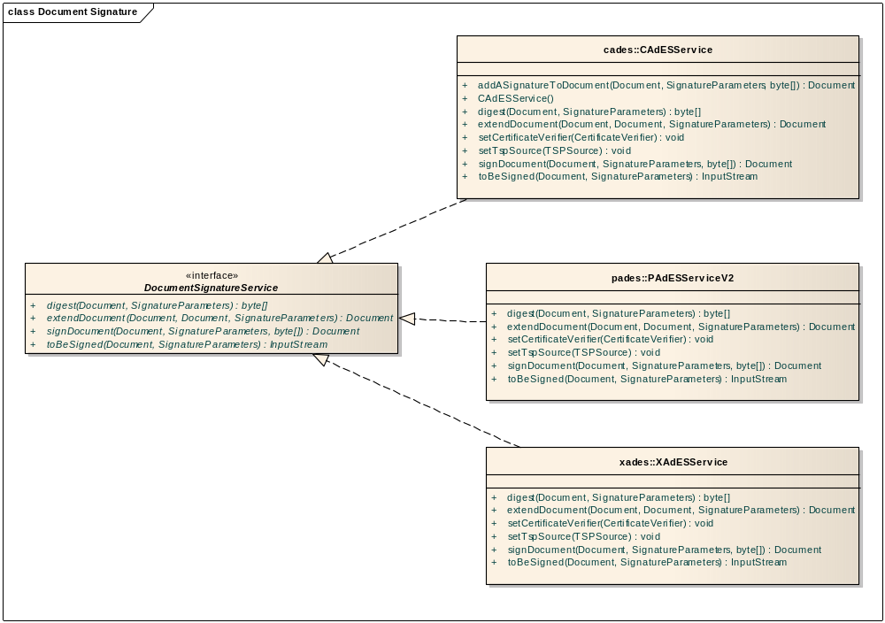
Figure 6: Implementation of DocumentSignatureService
The DSS project will provide three DocumentSignatureServices:
- PAdESService;
- CAdESService;
- XAdESService.
The interface DocumentSignatureService permits an easy integration for signing different document formats.

Integration of other Document Signature Format
By extending the DocumentSignatureService, it is easily possible to provide support for other document formats. Moreover, this eases the integration of formats of already existing frameworks like the eID DSSDocumentService or the Spanish @firma product.
An example is given in “Appendix II: Reuse FEDICT eID component” of how to reuse the eID implementation to provide support for native signature with ODF (OASIS Open Document Format) and OOXML (Microsoft Office XML).

Extending a signature
The BES and EPES levels contain “immutable” signed properties. Once the BES/EPES level created, these properties are “sealed” and cannot be changed.
The levels T/C/X/XL/A add unsigned data to the signature. This means that the properties of these levels can be added afterwards. DSS/Web is able to add these properties to any valid BES/EPES AdES.

Verification and Validation
The signature check is done in two steps:
- A mathematical verification of the signature, which consists in recomputing the digest of the document and comparing it to the one provided by the signature.
- A validation of the signer's certificate, which has to be trusted, as well as be qualified and supported by a SSCD.

Signature Verification
The mathematical verification (XML-DSig, CMS and PDF) is a subject that is already addressed by Java libraries, like Santuario [R03], BouncyCastle [R04] and iText [R05] respectively. The verification of properties specific for X/C/P-AdES and ASiC has to be implemented in the project.
The AdES’s concepts are implemented in the DocumentSignatureService. These elements are part of the DSS module.
Certificate validation is performed according to the new Trusted List topology. The Trusted Lists available from Member States, have to be consumable (provided that they follow the specification), as well as Trusted Lists created by TLManager. These lists are used to validate certificates and to determine if they are qualified and supported by a SSCD.

Certificate Validation
DSS checks the signature syntax and validate the associated certificates. This is a two step process:
- Built a certificate chain from the signing certificate to the issuers (maybe more than one) up to a Trust Anchor listed in a Trusted List.
- Check the “Qualification Status” as described in the SDI entry (ServiceDigitalIdentity) of the Trusted List. The certificate needs to be qualified and supported by a SSCD.

CertificateSource
For building this chain, certificates from different sources may be used:
- The Trusted Lists from Members States;
- The certificates contained at multiple places in the Signature;
- The URL referenced by the AIA attribute in certificates.
DSS will treat all these sources the same way using a CertificateSource abstraction.
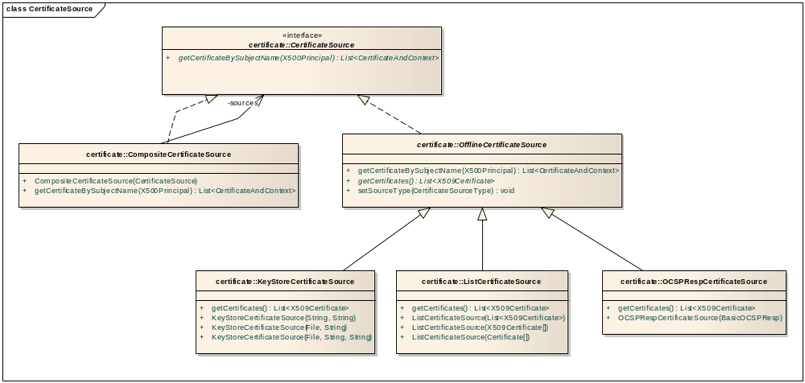
Figure 7: CertificateSource
DSS validates a signature towards the Trusted List model. This design allows integrating further CertificateSources, e.g. a specific CertificateSource to validate a Signature with a Trust Store.

CRLSource and OCSPSource
For every certificate, the validity has to be checked via CRL or OCSP responses. The information may originate from different CRLSources or OCSPSources:
- An advanced electronic signature in XL format that contains such information.
- Online resources (CRL servers, OCSP servers) that are specified in the certificate in question (e.g. AIA attribute, cRLDistributionPoint).
For easing the usage of such sources, DSS implements a CRLSource and OCSPSource interface, which offers a generic, uniform way of accessing CRL and OCSP sources. Furthermore, a caching mechanism can be easily attached to those sources, optimizing the access time to revocation information by reducing network connections to online servers.
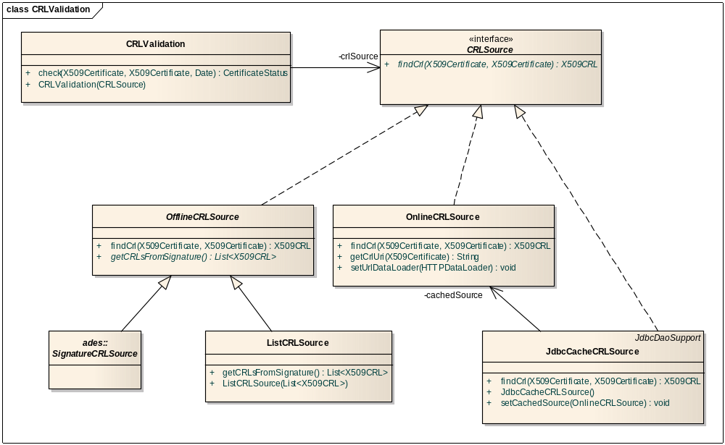
Figure 8: CRLSource
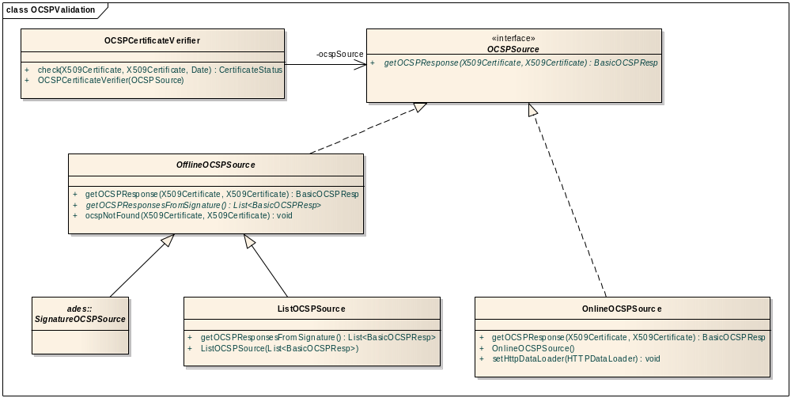
Figure 9: OCSPSource
After finding a Trust Anchor for the signing certificate in one of the Trusted Lists, DSS needs to check the qualification status of the signing certificate.
- If there is a SIE entry in the Trusted List, DSS checks the associated constraints to see if the certificate is qualified and supported by an SSCD.
- If there is no SIE entry or if the SIE:Q qualifier is “AsInCert”, DSS checks the ETSI QcCompliance Statement and/or the ETSI 101456 certificate policy OIDs from the certificate itself.

Cache Mechanism
Like mentioned in the DSS2-SAD (cf. [R01] 4.2.3.1 eSignatureService), a cache is maintained in a configurable database for storing certificate status information that was retrieved earlier from a CRL Server. The released implementation will use a HSQL database that stores data in-memory, as it is not expected to keep CRL and Certificate Status information for a very long time. Still, data can be kept over server restarts by exporting/importing it to the filesystem.
The CachedCRLSource will be responsible for this cache maintenance. It focuses only on caching aspects, and hosts an inline OnlineCRLSource to handle all the business aspects relative to the actual retrieval from online servers.

Validation algorithm for a Certificate

Definitions
Certificates, like OCSP responses and CRLs are signed. The concept SignedToken is used to abstract the algorithm from details.
A SignedToken is
- a signed piece of information
- by an issuer
- that may contain some other Certificate.
A SignedToken can also be considered as a CertificateSource, as described in 7.2.1 - CertificateSource.
A Certificate verifies a SignedToken when the signature of that SignedToken can be verified using the public key of the Certificate. The validity of a signature is limited in time (by the Certificate validity period). A Certificate that verifies a SignedToken is called the issuer of this SignedToken.
SignedToken validation is different depending on the type:
- CRL or OCSP response
The Certificate of the issuer of the CRL is needed. If the Certificate verifies the CRL or the OCSP response, then the Trust for the SignedToken is the same as the Trust for the Certificate. If there is no corresponding Certificate, the Trust is set as “unknown”.
- Certificate
The algorithm finds the issuer in the TrustedList or any other CertificateSource. A CRL or OCSP response is then needed to check the revocation status. The Trust for the Certificate is the same as the minimal Trust for the issuer Certificate and the CRL/OCSP response. If no issuer is found or no CRL/OCSP responses are retrieved, the Trust is set as “unknown”.

Algorithm
The algorithm is used in order to validate a Certificate C using the set TL of certificates defined in the Trusted List. The whole algorithm uses the time ST for verifying signatures. Even if the time ST is not explicitely used, every signature verification and revocation check must be retrieved for the specific time ST. Depending on the usage of the algorithm, the time ST can be the current time or the signing time.
The algorithm builds a ValidationContext that contains information needed for the construction of a Trust Chain between the Certificate and a potential trusted issuer found in a Trusted List:
- A list TBV (“To Be Validated”) of SignedTokens not having any RevocationData associated. That means that the validation for a SignedToken has not been attempted yet.
- An initially empty internal CertificateSource CERT_SOURCE.
The algorithm:
- First initializes the ValidationContext, then
- Iterates over TBV and for each element T of TBV will apply the validation iteration to T.

Initialisation
The initialisation is done by instantiating an empty ValidationContext.
The Certificate C is added to the TBV list.
The set TL of certificate from the TrustedList is added to CERT_SOURCE.
If an optional CertificateSource is provided, the Certificates are added to CERT_SOURCE.

Iteration
The algorithm iterates over the set of token TBV by executing the following steps.
The algorithm retrieves from the ValidationContext a SignedToken T from TBV. The CertificateSource from T is added to the internal source CERT_SOURCE. An iteration step may increase the size of CERT_SOURCE.
The issuer I of T is searched in CERT_SOURCE.
If an issuer I is found then:
- If T is a Certificate, the algorithm tries to contact an OCSP source and/or a CRL source in order to get the revocation status of the Certificate.
If a response is retrieved, a new SignedToken (for the CRL or OCSP response) is added to TBV. Otherwise the Trust cannot be defined on T (= “undefined”).
- If T is a CRL or an OCSP response, then the Trust of T is the same as I.
- If I is not in the TrustedList, I is added to TBV.
If no issuer is found, the Trust status is set as “undefined”.
T is removed from TBV.

End
The ValidationContext is complete, if there is no more SignedToken in TBV.
After the execution of the algorithm, the ValidationContext contains all information available to validate the Certificate C.
Best case Scenario:
- The ValidationContext contains the chain of certificate from C to one issuer in TL (certificates inside Trusted Lists).
- The ValidationContext contains the revocation data of each certificate of the chain at the time ST.
Worst case scenario:
- A piece of information (issuer, revocation status) couldn’t be retrieved and the Trust status of a SignedToken is set as undefined.
- No validated chain of certificates could be constructed between the signed certificate and a trusted issuer present in any Trusted List.
Even if some link of the chain couldn’t be validated, the ValidationContext contains all the available information and is suitable for building a report.

PDF Signature
PAdES signature requires the use of iText for handling PDFs.Without going into details of the format, signing a PDF consists in adding some entries at the end of the PDF. These entries describe the signature itself and how it is presented on the screen.
The example below shows the various elements of the simplest signature. Entry 7 contains the signature itself (CMS format). The signature is represented by the HexString in the key /Contents, it relates to areas of the document in /ByteRange. PAdES specifies that this area should be the entire document, except the value /Contents. The digest of the signature is calculated on the full /ByteRange by following the algorithm specified in /SubFilter (SHA-1).
7 0 obj
<</Contents <308006092a86488…> /Type/Sig/SubFilter/adbe.pkcs7.sha1/M(D:20110127153632+01'00')/ByteRange [0 980 8982 1202 ] /Filter/Adobe.PPKMS>>
endobj

The object 9 specifies the widget that defines how the signature is displayed on the screen. In this case, it is an invisible signature (/Rect size zero). The object references from other elements, such as value /V of signature (item 7), the page /P that contains the signature (item 4) and details of the signature display (appearance /AP, item 8).
9 0 obj
<</F 132/Type/Annot/Subtype/Widget/Rect[0 0 0 0]/FT/Sig/DR<<>>/T(Signature1)/V 7 0 R/P 4 0 R/AP<</N 8 0 R>>>>
endobj

Other objects are definitions of fonts and resources needed for displaying the signature.
10 0 obj
<</BaseFont/Helvetica/Type/Font/Subtype/Type1/Encoding/WinAnsiEncoding/Name/Helv>>
endobj

11 0 obj
<</BaseFont/ZapfDingbats/Type/Font/Subtype/Type1/Name/ZaDb>>
endobj

8 0 obj
<</Type/XObject/Resources<</ProcSet [/PDF /Text /ImageB /ImageC /ImageI]>>/Subtype/Form/BBox[0 0 0 0]/Matrix[1 0 0 1 0 0]/Length 8/FormType 1/Filter/FlateDecode>>stream
x�__
endstream
endobj

Two objects are overwritten by a new definition: This is the /Catalog that contains all the information in the PDF. It adds to the previous catalog an entry /AcroForm that references the widget signature.
When changing a PDF file, there is no possibility to insert an object. To overwrite a value, it is needed to add a new object with the same ID. Because the signing operation needs to add an /Annots attribute to the /Page dictionary and a /AcroForm attribute to the /Catalog dictionary, these two completed dictionaries are appended at the end of the PDF with the same ID than the previous version. This is the new /Catalog dictionary.
5 0 obj
<</Type/Catalog/AcroForm<</Fields[9 0 R]/DR<</Font<</Helv 10 0 R/ZaDb 11 0 R>>>>/DA(/Helv 0 Tf 0 g )/SigFlags 3>>/Pages 3 0 R>>
Endobj

The /Page dictionary is also overwritten using the same mechanism.
4 0 obj
<</Parent 3 0 R/Type/Page/Contents 2 0 R/Resources<</ProcSet[/PDF /Text /ImageB /ImageC /ImageI]/Font<</F1 1 0 R>>>>/MediaBox[0 0 595 842]/Annots[9 0 R]>>
endobj

iText
As stated in the DSS2-SAD (cf. [R01]), iText will be used for manipulation of PDF documents. It is already suited to work with PDF Signature and PDF Extensions that are necessary to provide a PAdES implementation.
However, iText injects more data than necessary when creating a signature, especially some time related information like the last update time and a randomly generated ID. Because DSS must produce every time the same results when the file and the parameters are the same, this behaviour had to be altered.
The “patched” version of iText is in the module dss-itext. This is a fork of iText 2.1.7. This version has been selected for licencing purposes.

WebServices
The main functionalities from DSS will be exposed by two SOAP web services, which provide four operations:
- Digest a document and return the digest.
- Sign a document by providing a document and a signed digest.
- Extend the signature level of a provided document.
- Validate the signature of a provided document.
These web services expose the core functionality of DSS and ease the integration of external and legacy applications.
The following chapters detail each operation by listing their WSDL contract. The WSDL definition of these web services is availaible from DSS WebService index page. By example for the local deployment: http://localhost:8080/dss-webapp/wservice.

Signature Service
<?xml version='1.0' encoding='UTF-8'?><wsdl:definitions name="SignatureService" targetNamespace="http://ws.dss.markt.ec.europa.eu/" xmlns:ns1="http://ws.dss.markt.ec.europa.eu/" xmlns:wsdl="http://schemas.xmlsoap.org/wsdl/" xmlns:xsd="http://www.w3.org/2001/XMLSchema">
<wsdl:types>
<xs:schema attributeFormDefault="unqualified" elementFormDefault="unqualified" targetNamespace="http://ws.dss.markt.ec.europa.eu/" xmlns:tns="http://ws.dss.markt.ec.europa.eu/" xmlns:xs="http://www.w3.org/2001/XMLSchema">
<xs:element name="digestDocument" type="tns:digestDocument"/>
<xs:element name="digestDocumentResponse" type="tns:digestDocumentResponse"/>
<xs:element name="extendSignature" type="tns:extendSignature"/>
<xs:element name="extendSignatureResponse" type="tns:extendSignatureResponse"/>
<xs:element name="signDocument" type="tns:signDocument"/>
<xs:element name="signDocumentResponse" type="tns:signDocumentResponse"/>
<xs:complexType name="signDocument">
<xs:sequence>
<xs:element minOccurs="0" name="document" type="tns:wsDocument"/>
<xs:element minOccurs="0" name="signedDigest" type="xs:base64Binary"/>
<xs:element minOccurs="0" name="signedProperties" type="tns:signedPropertiesContainer"/>
<xs:element minOccurs="0" name="signatureInfoLevel" type="tns:signatureFormat"/>
</xs:sequence>
</xs:complexType>
<xs:complexType name="wsDocument">
<xs:sequence>
<xs:element minOccurs="0" name="binary" type="xs:base64Binary"/>
</xs:sequence>
</xs:complexType>
<xs:complexType name="signedPropertiesContainer">
<xs:sequence>
<xs:element maxOccurs="unbounded" minOccurs="0" name="certificateChain" nillable="true" type="xs:base64Binary"/>
<xs:element minOccurs="0" name="claimedSignerRole" type="xs:string"/>
<xs:element minOccurs="0" name="signaturePackaging" type="xs:string"/>
<xs:element minOccurs="0" name="signaturePolicy" type="xs:string"/>
<xs:element minOccurs="0" name="signaturePolicyHashAlgo" type="xs:string"/>
<xs:element minOccurs="0" name="signaturePolicyHashValue" type="xs:base64Binary"/>
<xs:element minOccurs="0" name="signaturePolicyId" type="xs:string"/>
<xs:element minOccurs="0" name="signingCertificate" type="xs:base64Binary"/>
<xs:element minOccurs="0" name="signingDate" type="xs:dateTime"/>
</xs:sequence>
</xs:complexType>
<xs:complexType name="signDocumentResponse">
<xs:sequence>
<xs:element minOccurs="0" name="response" type="tns:wsDocument"/>
</xs:sequence>
</xs:complexType>
<xs:complexType name="extendSignature">
<xs:sequence>
<xs:element minOccurs="0" name="signedDocument" type="tns:wsDocument"/>
<xs:element minOccurs="0" name="originalDocument" type="tns:wsDocument"/>
<xs:element minOccurs="0" name="signatureInfoLevel" type="tns:signatureFormat"/>
</xs:sequence>
</xs:complexType>
<xs:complexType name="extendSignatureResponse">
<xs:sequence>
<xs:element minOccurs="0" name="response" type="tns:wsDocument"/>
</xs:sequence>
</xs:complexType>
<xs:complexType name="digestDocument">
<xs:sequence>
<xs:element minOccurs="0" name="document" type="tns:wsDocument"/>
<xs:element minOccurs="0" name="signedProperties" type="tns:signedPropertiesContainer"/>
<xs:element minOccurs="0" name="signatureInfo" type="tns:signatureFormat"/>
</xs:sequence>
</xs:complexType>
<xs:complexType name="digestDocumentResponse">
<xs:sequence>
<xs:element minOccurs="0" name="response" type="xs:base64Binary"/>
</xs:sequence>
</xs:complexType>
<xs:simpleType name="signatureFormat">
<xs:restriction base="xs:string">
<xs:enumeration value="XAdES_BES"/>
<xs:enumeration value="XAdES_EPES"/>
<xs:enumeration value="XAdES_T"/>
<xs:enumeration value="XAdES_C"/>
<xs:enumeration value="XAdES_X"/>
<xs:enumeration value="XAdES_XL"/>
<xs:enumeration value="XAdES_A"/>
<xs:enumeration value="CAdES_BES"/>
<xs:enumeration value="CAdES_EPES"/>
<xs:enumeration value="CAdES_T"/>
<xs:enumeration value="CAdES_C"/>
<xs:enumeration value="CAdES_X"/>
<xs:enumeration value="CAdES_XL"/>
<xs:enumeration value="CAdES_A"/>
<xs:enumeration value="PAdES_BES"/>
<xs:enumeration value="PAdES_EPES"/>
<xs:enumeration value="PAdES_LTV"/>
</xs:restriction>
</xs:simpleType>
<xs:element name="IOException" type="tns:IOException"/>
<xs:complexType name="IOException">
<xs:sequence/>
</xs:complexType>
</xs:schema>
</wsdl:types>
<wsdl:message name="IOException">
<wsdl:part element="ns1:IOException" name="IOException">
</wsdl:part>
</wsdl:message>
<wsdl:message name="digestDocumentResponse">
<wsdl:part element="ns1:digestDocumentResponse" name="parameters">
</wsdl:part>
</wsdl:message>
<wsdl:message name="signDocument">
<wsdl:part element="ns1:signDocument" name="parameters">
</wsdl:part>
</wsdl:message>
<wsdl:message name="extendSignature">
<wsdl:part element="ns1:extendSignature" name="parameters">
</wsdl:part>
</wsdl:message>
<wsdl:message name="signDocumentResponse">
<wsdl:part element="ns1:signDocumentResponse" name="parameters">
</wsdl:part>
</wsdl:message>
<wsdl:message name="digestDocument">
<wsdl:part element="ns1:digestDocument" name="parameters">
</wsdl:part>
</wsdl:message>
<wsdl:message name="extendSignatureResponse">
<wsdl:part element="ns1:extendSignatureResponse" name="parameters">
</wsdl:part>
</wsdl:message>
<wsdl:portType name="SignatureService">
<wsdl:operation name="signDocument">
<wsdl:input message="ns1:signDocument" name="signDocument">
</wsdl:input>
<wsdl:output message="ns1:signDocumentResponse" name="signDocumentResponse">
</wsdl:output>
<wsdl:fault message="ns1:IOException" name="IOException">
</wsdl:fault>
</wsdl:operation>
<wsdl:operation name="extendSignature">
<wsdl:input message="ns1:extendSignature" name="extendSignature">
</wsdl:input>
<wsdl:output message="ns1:extendSignatureResponse" name="extendSignatureResponse">
</wsdl:output>
<wsdl:fault message="ns1:IOException" name="IOException">
</wsdl:fault>
</wsdl:operation>
<wsdl:operation name="digestDocument">
<wsdl:input message="ns1:digestDocument" name="digestDocument">
</wsdl:input>
<wsdl:output message="ns1:digestDocumentResponse" name="digestDocumentResponse">
</wsdl:output>
<wsdl:fault message="ns1:IOException" name="IOException">
</wsdl:fault>
</wsdl:operation>
</wsdl:portType>
</wsdl:definitions>
Figure 10: Signature Service WSDL contract

Validation Service
<?xml version='1.0' encoding='UTF-8'?><wsdl:definitions name="ValidationService" targetNamespace="http://ws.dss.markt.ec.europa.eu/" xmlns:ns1="http://ws.dss.markt.ec.europa.eu/" xmlns:wsdl="http://schemas.xmlsoap.org/wsdl/" xmlns:xsd="http://www.w3.org/2001/XMLSchema">
<wsdl:types>
<xs:schema attributeFormDefault="unqualified" elementFormDefault="unqualified" targetNamespace="http://ws.dss.markt.ec.europa.eu/" xmlns:tns="http://ws.dss.markt.ec.europa.eu/" xmlns:xs="http://www.w3.org/2001/XMLSchema">
<xs:element name="validateDocument" type="tns:validateDocument"/>
<xs:element name="validateDocumentResponse" type="tns:validateDocumentResponse"/>
<xs:complexType name="validateDocument">
<xs:sequence>
<xs:element minOccurs="0" name="document" type="tns:wsDocument"/>
<xs:element minOccurs="0" name="originalDocument" type="tns:wsDocument"/>
</xs:sequence>
</xs:complexType>
<xs:complexType name="wsDocument">
<xs:sequence>
<xs:element minOccurs="0" name="binary" type="xs:base64Binary"/>
</xs:sequence>
</xs:complexType>
<xs:complexType name="validateDocumentResponse">
<xs:sequence>
<xs:element minOccurs="0" name="response" type="tns:wsValidationReport"/>
</xs:sequence>
</xs:complexType>
<xs:complexType name="wsValidationReport">
<xs:sequence>
<xs:element maxOccurs="unbounded" minOccurs="0" name="signatureInformationList" nillable="true" type="tns:wsSignatureInformation"/>
<xs:element minOccurs="0" name="timeInformation" type="tns:wsTimeInformation"/>
</xs:sequence>
</xs:complexType>
<xs:complexType name="wsSignatureInformation">
<xs:sequence>
<xs:element minOccurs="0" name="certPathRevocationAnalysis" type="tns:wsCertPathRevocationAnalysis"/>
<xs:element minOccurs="0" name="finalConclusion" type="xs:string"/>
<xs:element minOccurs="0" name="qcStatementInformation" type="tns:wsqcStatementInformation"/>
<xs:element minOccurs="0" name="qualificationsVerification" type="tns:wsQualificationsVerification"/>
<xs:element minOccurs="0" name="signatureLevelAnalysis" type="tns:wsSignatureLevelAnalysis"/>
<xs:element minOccurs="0" name="signatureVerification" type="tns:wsSignatureVerification"/>
</xs:sequence>
</xs:complexType>
<xs:complexType name="wsCertPathRevocationAnalysis">
<xs:sequence>
<xs:element maxOccurs="unbounded" minOccurs="0" name="certificatePathVerification" nillable="true" type="tns:wsCertificateVerification"/>
<xs:element minOccurs="0" name="summary" type="xs:string"/>
<xs:element minOccurs="0" name="trustedListInformation" type="tns:wsTrustedListInformation"/>
</xs:sequence>
</xs:complexType>
<xs:complexType name="wsCertificateVerification">
<xs:sequence>
<xs:element minOccurs="0" name="certificate" type="xs:base64Binary"/>
<xs:element minOccurs="0" name="certificateStatus" type="tns:wsRevocationVerificationResult"/>
<xs:element minOccurs="0" name="signatureVerification" type="tns:wsSignatureVerification"/>
<xs:element minOccurs="0" name="validityPeriodVerification" type="xs:string"/>
</xs:sequence>
</xs:complexType>
<xs:complexType name="wsRevocationVerificationResult">
<xs:sequence>
<xs:element minOccurs="0" name="issuer" type="xs:string"/>
<xs:element minOccurs="0" name="issuingTime" type="xs:dateTime"/>
<xs:element minOccurs="0" name="revocationDate" type="xs:dateTime"/>
<xs:element minOccurs="0" name="status" type="xs:string"/>
</xs:sequence>
</xs:complexType>
<xs:complexType name="wsSignatureVerification">
<xs:sequence>
<xs:element minOccurs="0" name="signatureAlgorithm" type="xs:string"/>
<xs:element minOccurs="0" name="signatureVerificationResult" type="xs:string"/>
</xs:sequence>
</xs:complexType>
<xs:complexType name="wsTrustedListInformation">
<xs:sequence>
<xs:element minOccurs="0" name="currentStatus" type="xs:string"/>
<xs:element minOccurs="0" name="currentStatusStartingDate" type="xs:dateTime"/>
<xs:element minOccurs="0" name="serviceName" type="xs:string"/>
<xs:element minOccurs="0" name="serviceType" type="xs:string"/>
<xs:element name="serviceWasFound" type="xs:boolean"/>
<xs:element minOccurs="0" name="statusAtReferenceTime" type="xs:string"/>
<xs:element minOccurs="0" name="statusStartingDateAtReferenceTime" type="xs:dateTime"/>
<xs:element minOccurs="0" name="tspElectronicAddress" type="xs:string"/>
<xs:element minOccurs="0" name="tspName" type="xs:string"/>
<xs:element minOccurs="0" name="tspPostalAddress" type="xs:string"/>
<xs:element minOccurs="0" name="tspTradeName" type="xs:string"/>
</xs:sequence>
</xs:complexType>
<xs:complexType name="wsqcStatementInformation">
<xs:sequence>
<xs:element minOccurs="0" name="qcCompliancePresent" type="xs:string"/>
<xs:element minOccurs="0" name="qcPPlusPresent" type="xs:string"/>
<xs:element minOccurs="0" name="qcPPresent" type="xs:string"/>
<xs:element minOccurs="0" name="qcSCCDPresent" type="xs:string"/>
</xs:sequence>
</xs:complexType>
<xs:complexType name="wsQualificationsVerification">
<xs:sequence>
<xs:element minOccurs="0" name="qcForLegalPerson" type="xs:string"/>
<xs:element minOccurs="0" name="qcNoSSCD" type="xs:string"/>
<xs:element minOccurs="0" name="qcSSCDStatusAsInCert" type="xs:string"/>
<xs:element minOccurs="0" name="qcWithSSCD" type="xs:string"/>
</xs:sequence>
</xs:complexType>
<xs:complexType name="wsSignatureLevelAnalysis">
<xs:sequence>
<xs:element minOccurs="0" name="levelA" type="tns:wsSignatureLevelA"/>
<xs:element minOccurs="0" name="levelBES" type="tns:wsSignatureLevelBES"/>
<xs:element minOccurs="0" name="levelC" type="tns:wsSignatureLevelC"/>
<xs:element minOccurs="0" name="levelEPES" type="tns:wsSignatureLevelEPES"/>
<xs:element minOccurs="0" name="levelLTV" type="tns:wsSignatureLevelLTV"/>
<xs:element minOccurs="0" name="levelT" type="tns:wsSignatureLevelT"/>
<xs:element minOccurs="0" name="levelX" type="tns:wsSignatureLevelX"/>
<xs:element minOccurs="0" name="levelXL" type="tns:wsSignatureLevelXL"/>
<xs:element minOccurs="0" name="signatureFormat" type="xs:string"/>
</xs:sequence>
</xs:complexType>
<xs:complexType name="wsSignatureLevelA">
<xs:sequence>
<xs:element maxOccurs="unbounded" minOccurs="0" name="archiveTimestampsVerification" nillable="true" type="tns:wsTimestampVerificationResult"/>
<xs:element minOccurs="0" name="levelReached" type="xs:string"/>
</xs:sequence>
</xs:complexType>
<xs:complexType name="wsTimestampVerificationResult">
<xs:sequence>
<xs:element minOccurs="0" name="certPathVerification" type="xs:string"/>
<xs:element minOccurs="0" name="creationTime" type="xs:dateTime"/>
<xs:element minOccurs="0" name="issuerName" type="xs:string"/>
<xs:element minOccurs="0" name="sameDigest" type="xs:string"/>
<xs:element minOccurs="0" name="serialNumber" type="xs:string"/>
<xs:element minOccurs="0" name="signatureAlgorithm" type="xs:string"/>
</xs:sequence>
</xs:complexType>
<xs:complexType name="wsSignatureLevelBES">
<xs:sequence>
<xs:element maxOccurs="unbounded" minOccurs="0" name="certificates" nillable="true" type="xs:base64Binary"/>
<xs:element minOccurs="0" name="levelReached" type="xs:string"/>
<xs:element minOccurs="0" name="signingCertRefVerification" type="xs:string"/>
<xs:element minOccurs="0" name="signingCertificate" type="xs:base64Binary"/>
</xs:sequence>
</xs:complexType>
<xs:complexType name="wsSignatureLevelC">
<xs:sequence>
<xs:element minOccurs="0" name="certificateRefsVerification" type="xs:string"/>
<xs:element minOccurs="0" name="levelReached" type="xs:string"/>
<xs:element minOccurs="0" name="revocationRefsVerification" type="xs:string"/>
</xs:sequence>
</xs:complexType>
<xs:complexType name="wsSignatureLevelEPES">
<xs:sequence>
<xs:element minOccurs="0" name="levelReached" type="xs:string"/>
<xs:element minOccurs="0" name="policyValue" type="xs:string"/>
</xs:sequence>
</xs:complexType>
<xs:complexType name="wsSignatureLevelLTV">
<xs:sequence>
<xs:element minOccurs="0" name="levelReached" type="xs:string"/>
</xs:sequence>
</xs:complexType>
<xs:complexType name="wsSignatureLevelT">
<xs:sequence>
<xs:element minOccurs="0" name="levelReached" type="xs:string"/>
<xs:element maxOccurs="unbounded" minOccurs="0" name="signatureTimestampsVerification" nillable="true" type="tns:wsTimestampVerificationResult"/>
</xs:sequence>
</xs:complexType>
<xs:complexType name="wsSignatureLevelX">
<xs:sequence>
<xs:element minOccurs="0" name="levelReached" type="xs:string"/>
<xs:element maxOccurs="unbounded" minOccurs="0" name="referencesTimestampsVerification" nillable="true" type="tns:wsTimestampVerificationResult"/>
<xs:element maxOccurs="unbounded" minOccurs="0" name="signatureAndRefsTimestampsVerification" nillable="true" type="tns:wsTimestampVerificationResult"/>
</xs:sequence>
</xs:complexType>
<xs:complexType name="wsSignatureLevelXL">
<xs:sequence>
<xs:element minOccurs="0" name="certificateValuesVerification" type="xs:string"/>
<xs:element minOccurs="0" name="levelReached" type="xs:string"/>
<xs:element minOccurs="0" name="revocationValuesVerification" type="xs:string"/>
</xs:sequence>
</xs:complexType>
<xs:complexType name="wsTimeInformation">
<xs:sequence>
<xs:element minOccurs="0" name="verificationTime" type="xs:dateTime"/>
</xs:sequence>
</xs:complexType>
<xs:element name="IOException" type="tns:IOException"/>
<xs:complexType name="IOException">
<xs:sequence/>
</xs:complexType>
</xs:schema>
</wsdl:types>
<wsdl:message name="IOException">
<wsdl:part element="ns1:IOException" name="IOException">
</wsdl:part>
</wsdl:message>
<wsdl:message name="validateDocumentResponse">
<wsdl:part element="ns1:validateDocumentResponse" name="parameters">
</wsdl:part>
</wsdl:message>
<wsdl:message name="validateDocument">
<wsdl:part element="ns1:validateDocument" name="parameters">
</wsdl:part>
</wsdl:message>
<wsdl:portType name="ValidationService">
<wsdl:operation name="validateDocument">
<wsdl:input message="ns1:validateDocument" name="validateDocument">
</wsdl:input>
<wsdl:output message="ns1:validateDocumentResponse" name="validateDocumentResponse">
</wsdl:output>
<wsdl:fault message="ns1:IOException" name="IOException">
</wsdl:fault>
</wsdl:operation>
</wsdl:portType>
</wsdl:definitions>
Figure 11: Validation Service WSDL contract

TLManager
TLManager is a Java Swing application that permits the creation and editing of a Member State Trusted List (TL) as well as the List of Trusted Lists (LOTL). These lists must respect the specifications from ETSI, refined by [R10].
It is a standalone application and consists of classical n-tier architecture elements:

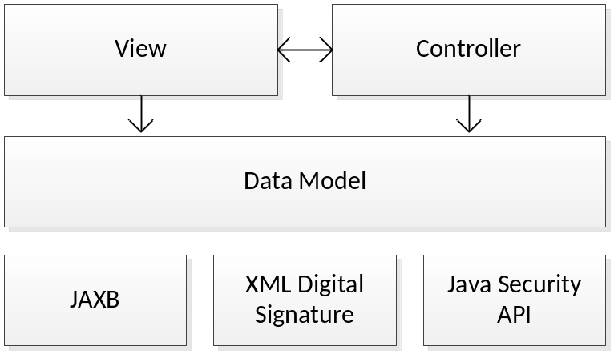
Figure 12: Layers of TLManager

- A presentation layer composed by the view and a controller component that holds all GUI related components. This layer is described in chapter 10.1 - Presentation Layer.
- A business layer, represented by the data model, that takes all rules into account related to the manipulation of Trusted Lists. It also contains features for opening an existing List and signing a completed List before publishing it. The business layer will aggregate all the rules about creating and manipulating a List. This permits to have a clear view of how objects are created and retrieved from the data layer. The business rules are described in chapter 4.2 of [R09] and the business layer is further detailed in chapter 10.2 - Business Layer.
- A persistence layer described in chapter 10.3 - Persistence Layer.
The following table shows the relation of these three layers with the appropriate packages and modules:
Layer | Package | Module
Presentation | eu.europa.ec.markt.tlmanager.model.*;  eu.europa.ec.markt.tlmanager.view.*;  eu.europa.ec.markt.tlmanager.controller.* | tlmanager-ui; tlmanager-ui-components
Business | eu.europa.ec.markt.tlmanager.core.* | tlmanager-core
Persistence | eu.europa.ec.markt.tsl.jaxb.* | dss-common

Presentation Layer
The view package contains every component that is displayed to the user. The content of a TSL is distributed over 7 different pages; each corresponding to a specific level in the hierarchical structure of a TSL (Xsd Element). Each page is associated to a specific type of DefaultMutableTreeNode in the JTree that is used to structure the content.

Page class | Node | Xsd Element
TSLInformationPage | TSLRootNode | TrustStatusListType
PointerToOtherTSLPage | PointerNode | OtherTSLPointerType
TSPInformationPage | TSPNode | TSPType
ServiceCurrentStatusInformationPage | ServiceNode | TSPServiceType
ServiceStatusHistoryPage | HistoryNode | ServiceHistoryInstanceType
ServiceInformationExtensionPage | ExtensionNode | ExtensionsListType
QualificationExtensionPage | QualificationNode | QualificationElementType

The following figure shows the relations between the MainFrame and the content pages:
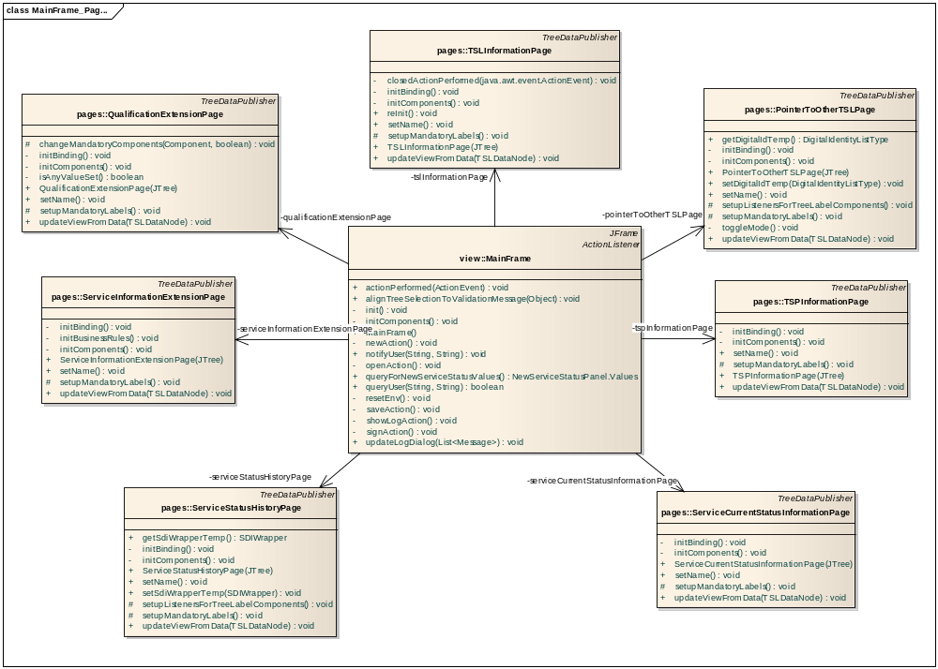
Figure 13: MainFrame and content pages
Each page is derived from a TreeDataPublisher:
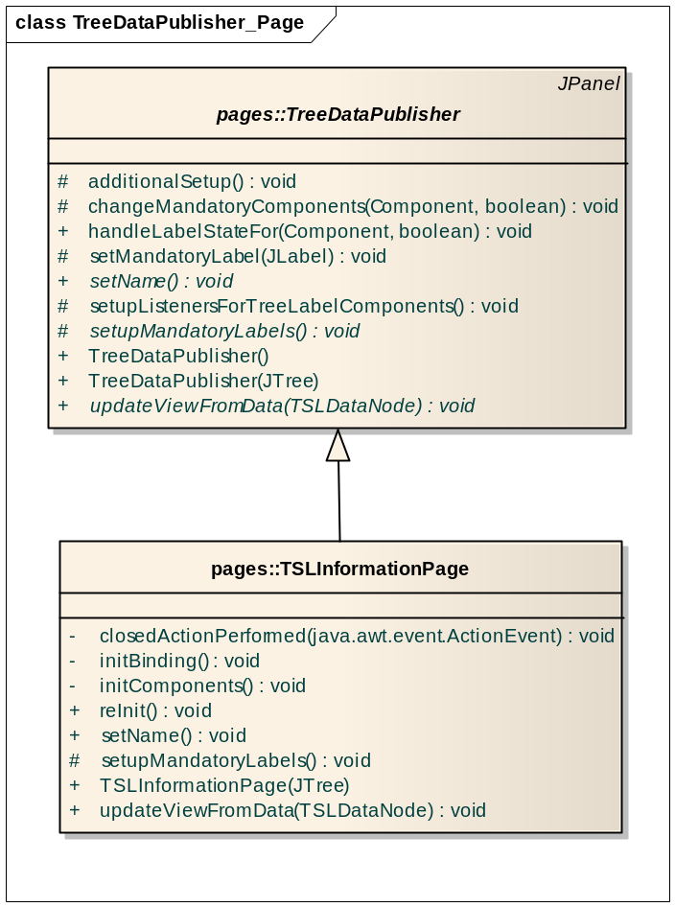
Figure 14: TreeDataPublisher and a content page
The following methods need to be implemented (among others):
- public abstract void setName();
Sets a name for the page, to ensure that TSLDataNode.getAssociatedDataPublisherName() returns something when it is called within the TreeSelectionHandler of the used JTree.

- protected abstract void setupMandatoryLabels();
This has to be implemented to add any JLabel of the content page to the set of MandatoryLabels that is maintained by TreeDataPublisher. A mandatory label is displayed in red as long as its associated component is empty.

- public abstract void updateViewFromData(TSLDataNode data);
This method is called from the TreeSelectionHandler of the used JTree whenever a value has changed (TreeSelectionListener.valueChanged(TreeSelectionEvent e)). It updates the bindings of the BindingManager; cf. chapter 10.1.1 - Binding.

Binding
TLManager integrates org.jdesktop.beansbinding for dynamically binding of bean values to components. The used beans are created from the xsd definitions (cf. chapter 10.3 - Persistence Layer) and the components are mainly out of the box swing components, but may also be custom components as described in 10.1.2 - Additional components.
All necessary classes are subpackaged in eu.europa.ec.markt.tlmanager.view.binding. The class BindingManager is instantiated by each component page to manage all bindings per page.

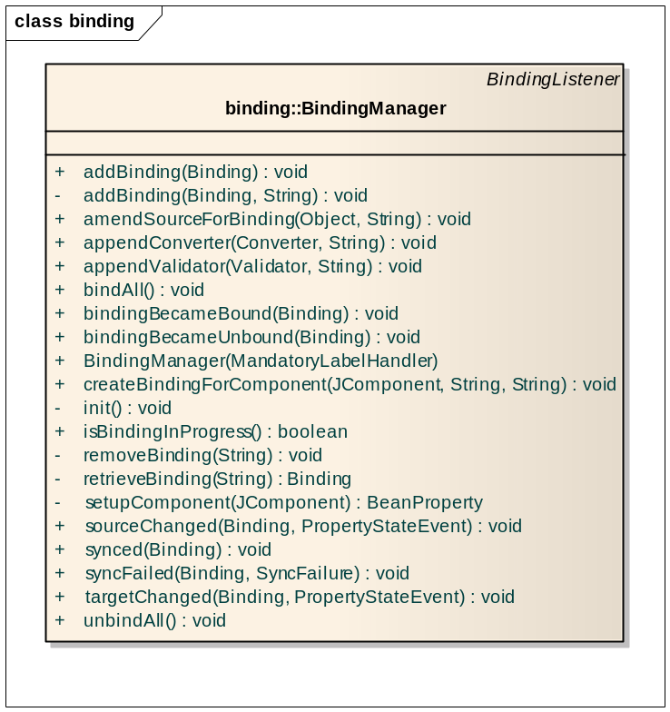
Figure 15: The BindingManager
The action of the BindingManager is mainly centered on two methods:
- public void createBindingForComponent(JComponent component, String sourceBeanProperty, String name)
Creates a new binding (used during initialisation of the content pages) and adds it to the map of bindings that is maintained in the BindingManager. The JComponent has to be of a known type to be able to create a BeanProperty. E.g. in case of a JTextField, the property is ‘text’. Furthermore the property of the source bean has to be provided, which must match the appropriate variable of the jaxb object. The attribute ‘name’ distinguishes the different bindings; it has to match the name used in the following method.

- public void amendSourceForBinding(Object source, String name)
If a source bean has changed, this method is used and the changed source bean is provided along with a name to distinguish the bindings (find out the correct binding in the map of BindingManager).

Converter
Additionally to the binding mechanism described in the previous chapter, it may be needed to have converters doing the conversion of the type of data coming from the component to the type of data that is used in the beans (jaxb objects).
Such converters can be attached to a binding with the following method during initialisation time:
- public void appendConverter(Converter converter, String name)
Converter has to be a class that extends org.jdesktop.beansbinding.Converter and is called automatically when a binding action occurs. Converters often call an additional Adapter to do the actual work. The attribute ‘name’ distinguishes the different bindings; it has to match to a name of a binding, which was already created before.

Additional components
For representing all the data in TLManager, more components are needed than the standard out of the box swing components.

Content Components for Multivalue Dialogs
Multivalue dialogs collect data for each language code, or for an arbitrary number of entries, where each may have different content panels for entering the data.

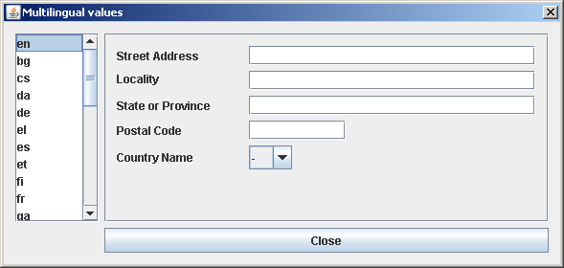
Figure 16: Example of a MultivalueDialog for Multilingual values and PostalContent

The following figure shows the relation between the classes:
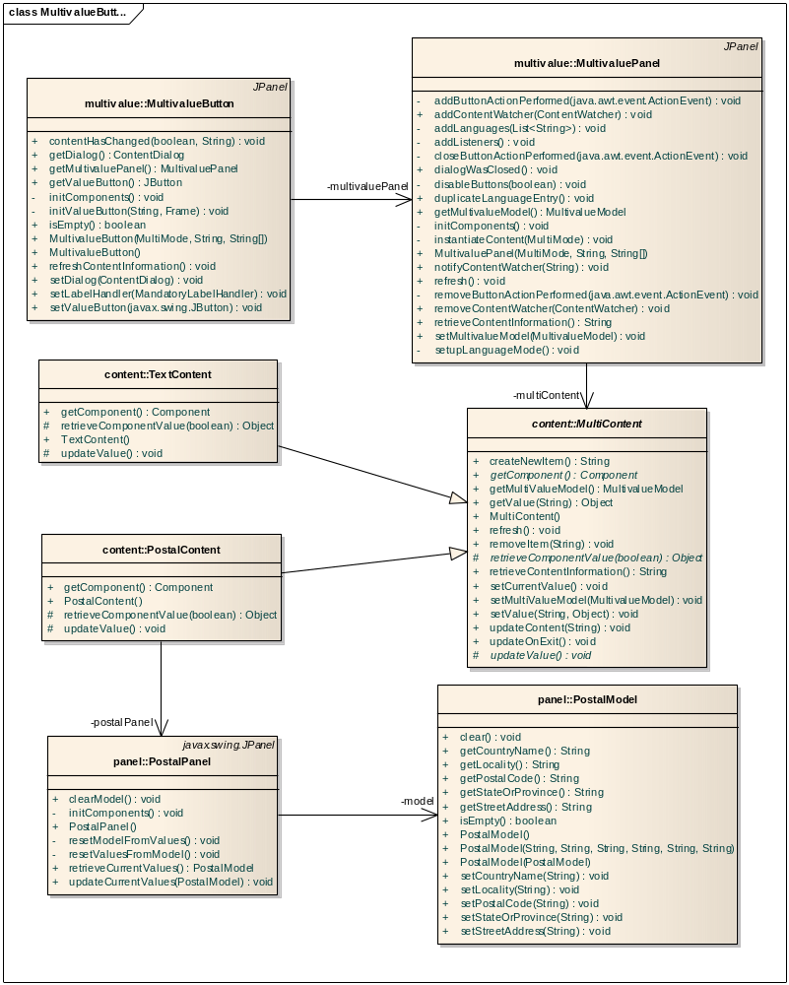
Figure 17: Multivalue classes with two exemplary content implementations

In either case, the MultivaluePanels are displayed with the help of a MultivalueButton, which is placed on the content pages. Depending on the constructor of this button, the shown panel is different:
- public MultivalueButton(MultiMode multiMode, String mandatoryValue, String[] multiConfValues)
The first attribute is a differentiation of the mode by the enumeration MultiMode; cf. the table below. If there are any values which should be respected in the renderer for the JList in the MultivaluePanel, they can be specified as mandatoryValue. In case of additional configuration values (which are only used for ComboBoxContent, they can be given as third attribute.

MultiMode | Usage
LING_NORMAL | Lingual values and TextContent
LING_POSTAL | Lingual values and PostalContent
MULTI_ANYURI | Multiple values and AnyUriContent
MULTI_FREE | Multiple values and TextContent
MULTI_FIX | Multiple values and ComboBoxContent
MULTI_ASI | Multiple values and AdditionalServiceInformationContent
MULTI_TSPINEX | Multiple values and TSPInformationExtensionContent

Any textual content or content that can be represented by a JComboBox does not need a special content implementation. For the rest, the following table shows the available implementations:

Xsd Element | Content | Panel
AdditionalServiceInformationType | AdditionalServiceInformationContent | AdditionalServiceInformationPanel
ElectronicAddressType | ElectronicContent | ElectronicPanel
PostalAddressType | PostalContent | PostalPanel
ExtensionsListType | TSPInformationExtensionContent | TSPInformationExtensionPanel

DateTimePicker
This component collects data for a date and a time. For selecting a date, the component JXDatePicker from SwingX framework [R06] is used and for the time, a JSpinner is used.

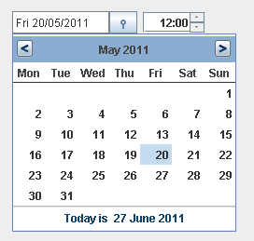
Figure 18: DateTimePicker

Certificate Viewer
Some of the fields of a TSL contain X.509 certificates (encoded as Base64). To have a human readable representation of the encoded certificates a CertificatePanel is used. It is shown by pressing on a CertificateButton, which is placed on a content page.
With the ‘Select Certificate’ a JFileChooser is opened, to select a certificate file.
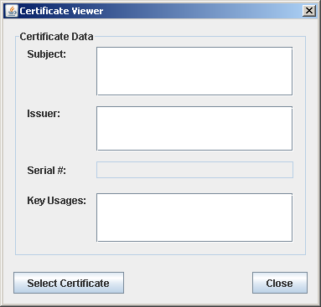
Figure 19: Certificate Viewer without data

Business Layer
The business layer is responsible for the manipulations of the TSL. It implements the use cases from the DSS-FAD [R09].
The main tasks are:
- Open an existing compliant TSL.
- Export and sign the current TSL. The first step of the signing operation is dedicated to validation of the TSL. Any errors or warnings are shown as a result.
- Pre-fill some fields with default values according to the configuration and the state of the current TSL.

Layer Interaction
Communication between the Business Layer and the Presentation Layer are done using the Observer/Observable pattern. The presentation components, like TSLTreeModel implement the Observer interface and register themselves to the TSLComposer (which extends the Observable class).
When a user interacts with a visual component, the appropriate controller translates the action of the user in a call to the TSLComposer. If one operation results in a change of states of the TSL data, then the TSLComposer notifies the registered Observers in order to update them.
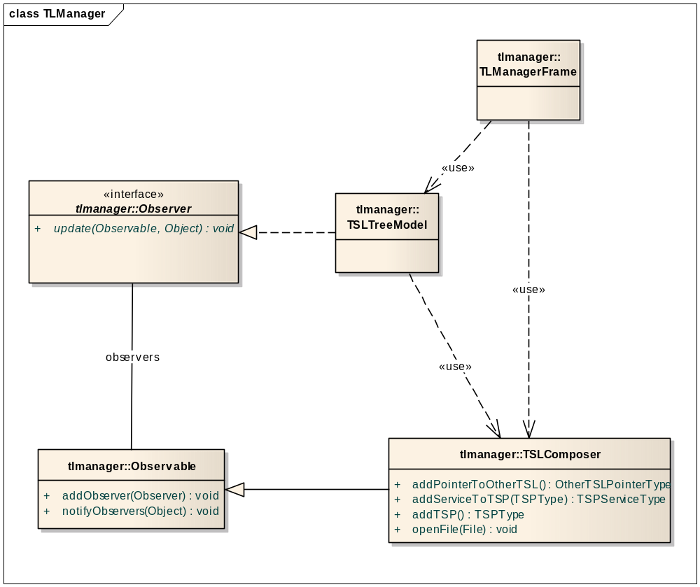
Figure 20: Interaction between the layers

Object prefilling
When a new TSL is created, or an existing TSL is loaded, jaxb objects are generated (cf. chapter 10.3 - Persistence Layer). To be able to do a proper binding to these objects, they have to be in a consistent state. To ensure that this state is reached, the ObjectFiller class is used.
The following figure gives an idea of the available methods:

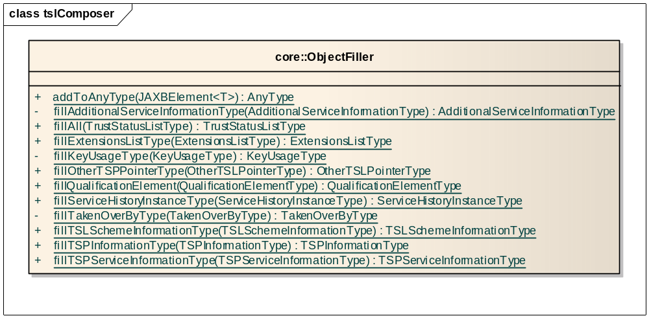
Figure 21: ObjectFiller class

ObjectFiller.fillAll(tsl) is used from TSLComposer in the case of a new or loaded TSL.

Validation and Signing
The validation is a two-phase process. In the first phase, all mandatory values are checked and in the second phase, any business rule is verified. If there are errors during the first phase, the second phase is not started.
When the validation is finished, TLManager will produce a signed XML using the appropriate “Document Signer Service” (see 6 - Document Signer Service).
All methods for mandatory checks are prefixed with ‘checkMandatory’. All methods for checking of business rules are prefixed with ‘checkRule’. These methods are called via reflection, which also means that they are invoked in the order they appear in the class.
The following figure gives an idea of the available methods:
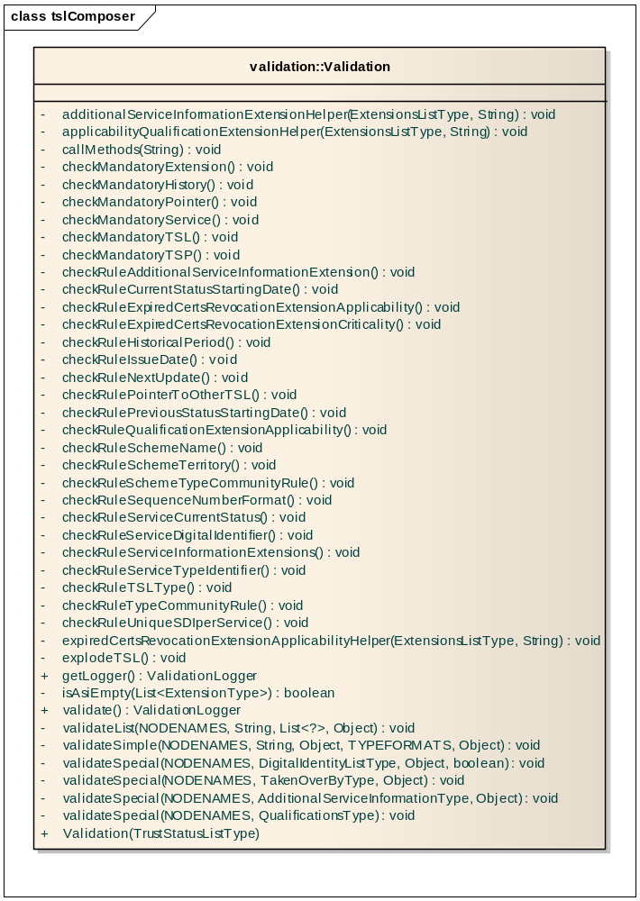
Figure 22: Validation class

Persistence Layer
The format of any TSL follows ETSI 102 231 v3.1.2 (cf. [R08]) supplemented by 2009/767/EC (cf. [R10]) as amended by 2010/425/EU (cf. [R12]). Java provides an API called JAXB (Java Architecture for XML Binding) that automatically generates object representations from XML documents and vice versa. This way, the XML files that specify the format of a TSL, is abstracted in Java objects and can be dealt with conveniently.
A sample of generated classes is shown in Figure 23: Sample of classes generated by JAXB.
The applications TLManager and DSS/Web use the same module to handle Trusted Lists. This module will implement the following official XML schemas:
- ts_102231v030102_xsd.xsd;
- ts_102231v030102_additionaltypes_xsd.xsd;
- ts_102231v030102_sie_xsd.xsd.
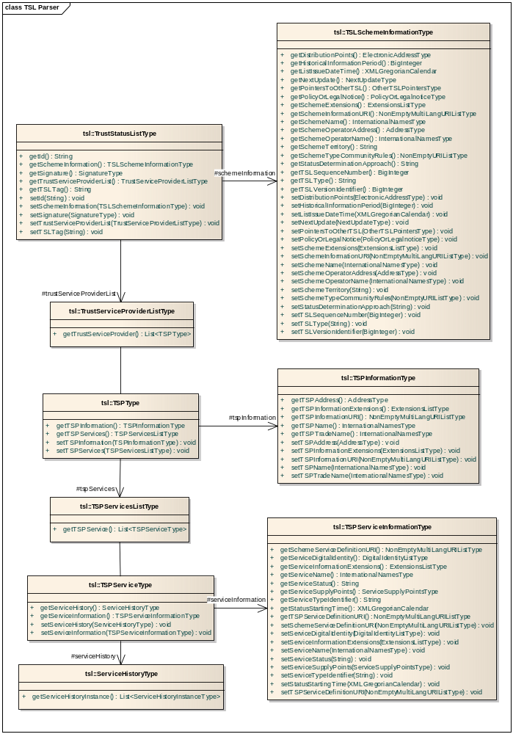
Figure 23: Sample of classes generated by JAXB

CONFIGURATION FILE
TLManager has many configuration values, which are taken from a property-file called ‘tlManager.properties’. These configuration values are further detailed in [R09].
Since TLManager can be started in two different modes, there is a set of values for each mode, as well as some values which are used in common. The class which makes these configuration values available to other classes is called Configuration. It has the following method:
- public TSL getTSL()
Takes the mode into account and returns the appropriate TSL; either a TL or a LOTL.

The following figure shows the implementations of a TSL:
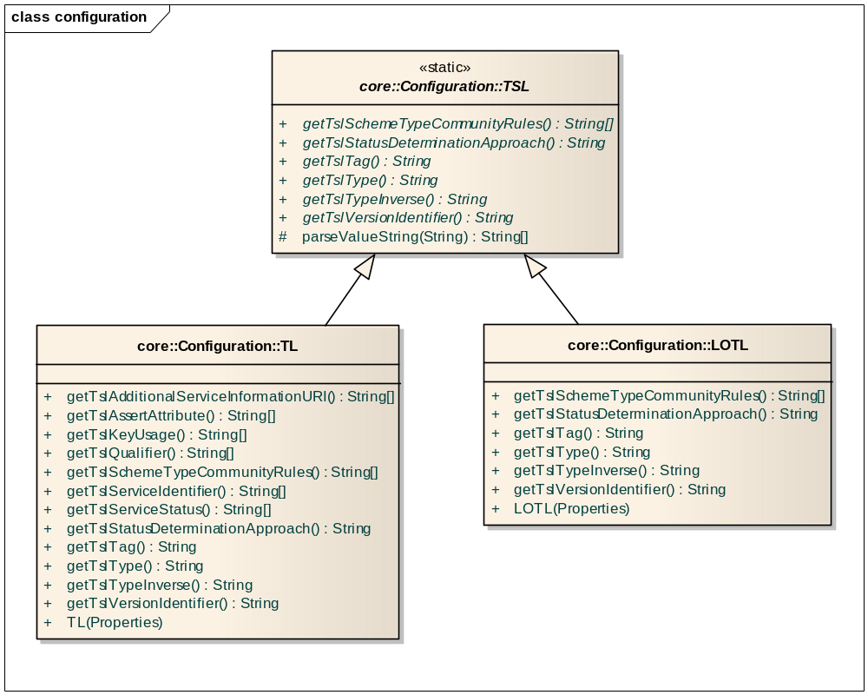
Figure 24: Implementations of a TSL

Appendix I: How to use Java PC/SC
As described in “5.1 - Signature Tokens”, one can easily add another implementation of the SignatureTokenConnection, thus enabling the SignatureApplet to use other API than the provided three (PKCS#11, PKCS#12 and MS CAPI).
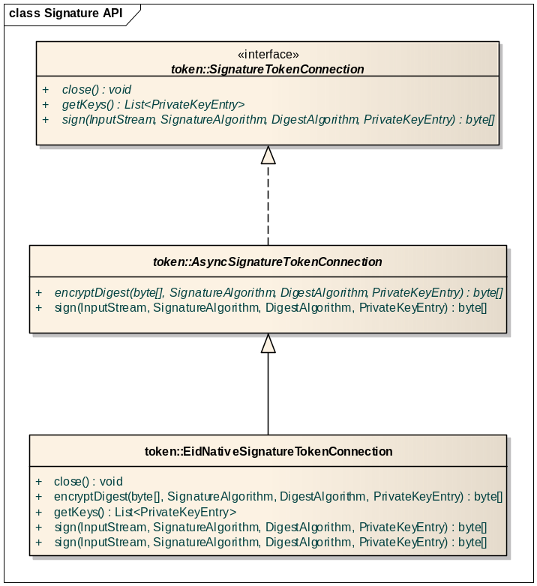
Figure 25: Implementation of SignatureTokenConnection for Java 6 IO PC/SC
For example, it is likely that in the future PC/SC will be the preferred way of accessing a Smartcard. Although PKCS#11 is currently the most used API, DSS is extensible and can use PC/SC.
The proposed design in this example is to use PC/SC to communicate with the Smartcard. A PCSC implementation of the signature token should extend AsyncSignatureTokenConnection.
Sample source-code is provided for the BeID smartcard. All the PCSC aspects are handled by the maven module eid-applet-core. The EidNativeSignatureTokenConnection is an adapter between AsyncSignatureTokenConnection and the class PcscEid.

=============================== EidNativeSignatureTokenConnection.java
package net.naramski.labs.signature.applet.beid;

import eu.europa.ec.markt.dss.DigestAlgorithm;
import eu.europa.ec.markt.dss.SignatureAlgorithm;
import eu.europa.ec.markt.dss.signature.token.AsyncSignatureTokenConnection;
import eu.europa.ec.markt.dss.signature.token.DSSPrivateKeyEntry;

import java.io.IOException;
import java.security.KeyStoreException;
import java.security.NoSuchAlgorithmException;
import java.security.cert.CertificateException;
import java.security.cert.X509Certificate;
import java.util.ArrayList;
import java.util.List;
import java.util.Locale;
import java.util.logging.Level;
import java.util.logging.Logger;

import javax.smartcardio.CardException;

import be.fedict.eid.applet.Messages;
import be.fedict.eid.applet.sc.PcscEid;

public class EidNativeSignatureTokenConnection extends AsyncSignatureTokenConnection {

private PcscEid eid;

/**
* The default constructor for BeidNativeSignatureTokenConnection.
*/
public EidNativeSignatureTokenConnection(AppletView view) {
this.eid = new PcscEid(view, new Messages(Locale.ENGLISH));
}

@Override
public void close() {
eid.close();
}

@Override
public List<DSSPrivateKeyEntry> getKeys() throws KeyStoreException {
try {
eid.isEidPresent();
List<X509Certificate> signatureChain = eid.getSignCertificateChain();
List<DSSPrivateKeyEntry> entries = new ArrayList<DSSPrivateKeyEntry>();
entries.add(new EidPrivateKeyEntry(signatureChain.get(0), signatureChain));
return entries;
} catch (CardException ex) {
Logger.getLogger(EidNativeSignatureTokenConnection.class.getName()).log(Level.SEVERE, null, ex);
throw new KeyStoreException(ex);
} catch (IOException ex) {
Logger.getLogger(EidNativeSignatureTokenConnection.class.getName()).log(Level.SEVERE, null, ex);
throw new KeyStoreException(ex);
} catch (CertificateException ex) {
Logger.getLogger(EidNativeSignatureTokenConnection.class.getName()).log(Level.SEVERE, null, ex);
throw new KeyStoreException(ex);
}
}

@Override
public byte[] encryptDigest(byte[] digestValue, SignatureAlgorithm signatureAlgo, DigestAlgorithm digestAlgo,
DSSPrivateKeyEntry keyEntry) throws NoSuchAlgorithmException {
try {
eid.isEidPresent();
return eid.sign(digestValue, digestAlgo.getName());
} catch (CardException ex) {
Logger.getLogger(EidNativeSignatureTokenConnection.class.getName()).log(Level.SEVERE, null, ex);
throw new RuntimeException(ex);
} catch (IOException ex) {
Logger.getLogger(EidNativeSignatureTokenConnection.class.getName()).log(Level.SEVERE, null, ex);
throw new RuntimeException(ex);
} catch (InterruptedException ex) {
Logger.getLogger(EidNativeSignatureTokenConnection.class.getName()).log(Level.SEVERE, null, ex);
throw new RuntimeException(ex);
}
}

}

=============================== EidPrivateKeyEntry.java

package net.naramski.labs.signature.applet.beid;

import eu.europa.ec.markt.dss.signature.token.DSSPrivateKeyEntry;

import java.security.cert.Certificate;
import java.security.cert.X509Certificate;
import java.util.List;

/**
* Sample for eID
*
*/
public class EidPrivateKeyEntry implements DSSPrivateKeyEntry {

private X509Certificate certificate;

private Certificate[] certificateChain;

public EidPrivateKeyEntry(X509Certificate certificate, List<X509Certificate> chain) {
this.certificate = certificate;
certificateChain = new Certificate[chain.size()];
certificateChain = chain.toArray(certificateChain);
}

@Override
public X509Certificate getCertificate() {
return certificate;
}

@Override
public Certificate[] getCertificateChain() {
return certificateChain;
}

}

=============================== AppletView.java

package net.naramski.labs.signature.applet.beid;

import java.awt.Component;

import javax.swing.JApplet;

import be.fedict.eid.applet.DiagnosticTests;
import be.fedict.eid.applet.Messages;
import be.fedict.eid.applet.Status;
import be.fedict.eid.applet.View;

public class AppletView implements View {

private JApplet applet;

/**
* The default constructor for AppletView.
*/
public AppletView(JApplet applet) {
this.applet = applet;
}

@Override
public void addDetailMessage(String detailMessage) {
}

@Override
public Component getParentComponent() {
return applet;
}

@Override
public boolean privacyQuestion(boolean includeAddress, boolean includePhoto, String identityDataUsage) {
return false;
}

@Override
public void setStatusMessage(Status status, Messages.MESSAGE_ID messageId) {
}

@Override
public void addTestResult(DiagnosticTests diagnosticTest, boolean success, String description) {
}

@Override
public void setProgressIndeterminate() {
}

@Override
public void resetProgress(int max) {
}

@Override
public void increaseProgress() {
}
}

Appendix II: Reuse FEDICT eID component
The eID implementation provides already a signing functionality for XML based document formats. In order to reuse the eID component, a FedictDSSAdapter could be created that ease the utilisation of DSSDocumentService from eID. Thus, the DSS project will be able to use the current and future signature components from the eID framework.
DSS will not directly support native signatures for ODF (OASIS’ Open Document Format) and OOXML (Microsoft’s Office Open XML), but the FedictDSSAdapter can be used for this. This is considered to be an Extension point.
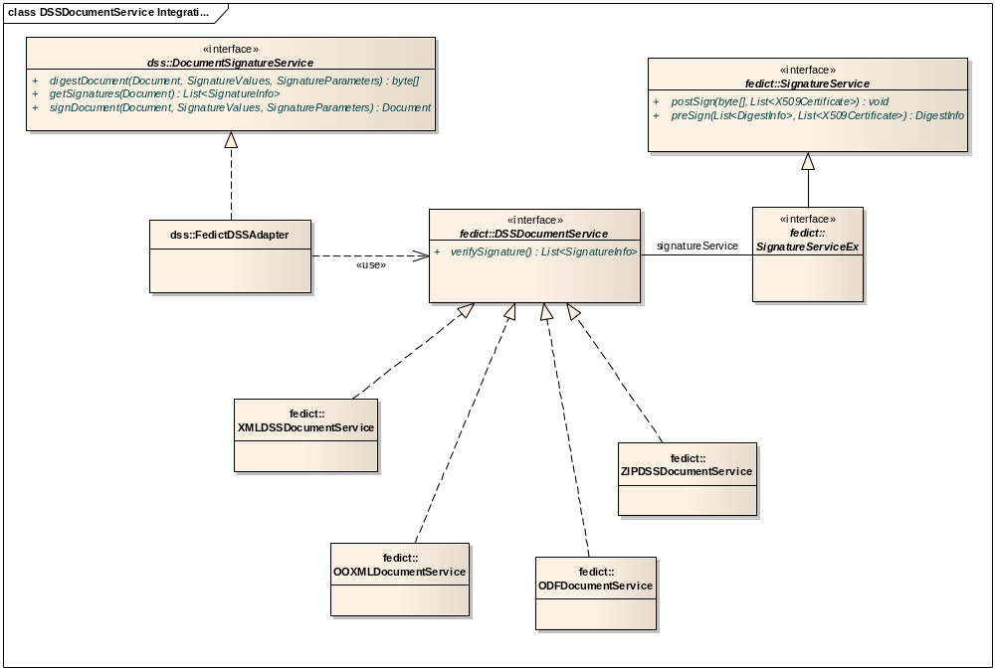
Figure 26: DSSDocumentService Class Diagram

DSSDocumentService interface encapsulates all the details of handling a file for the validation/creation aspects of e-signatures. The interface DSSDocumentService has two methods related to document signatures.
- getSignatureService() returns an object that implements SignatureServiceEx and knows how to calculate a digest and sign a document. The governing interface SignatureService ensures that the methods postSign() and preSign() may be called before or after signing respectively.
- verifySignatures() returns a list of SignatureInfo objects that hold informations about each signature contained in the document. This method is used during the validation of signatures in the document.

Appendix III: Validation report structure

Introduction
This section describes the fields provided in the validation report. The content of these fields are recovered from the verification performed during the validation algorithm.

Used type
To facilitate the readability of the validation report structure, the following information type has been used along the description.
Result type
The “Result type” is used to indicate the success or the failure of individual verification steps. It is defined as follows:
- Result: indicates whether the result of the verification step is:
  - Valid;
  - Invalid;
  - Undetermined;
- Description: provides additional information about the result of the verification step. In particular it provides explanation in case of invalid or undetermined result.

Revocation verification type
The “Revocation verification type” is used to indicate the success or the failure of the verification of revocation data. It is defined as follows:
- Status: contains the status of the certificate, specifies if the certificate is revoked or not;
- Revocation date: if the certificate is revoked, this element contains the date and time of revocation;
- Issuer: if the certificate is revoked, specifies the name of the issuer of the revocation data;
- Issuing time: if the certificate is revoked, specifies the date and time at which the revocation data has been issued.
Time stamp verification type
The “Time stamp verification type” is used to indicate the success or the failure of the verification of a time stamp. It is defined as follows:
- Format (Result type): indicates whether the format of the time stamp is ok or not;
- Time stamp content: contains the content of the time stamp:
  - Serial number;
  - Creation time;
  - Issuer name;
- Signature verification: contains information about the validity of the signature of the time stamp:
  - Signature verification (Result type): specifies if the signature is mathematically correct or not;
  - Signature algorithm: provides the name of the algorithm applied for the signature.
- Certificates path verification (Result type): indicates whether the certificate path of the time stamp has been verified up to a trusted list.

Validation report

Time information
Verification time
Specifies the date and time in which the validation has been launched.

Signature information
For each signature, the verification algorithm provides the following information in the validation report.
Signature structure verification (Result type)
Specifies if the structure of the signature is syntactically correct or not, according to the signature format (CAdES, XAdES or PAdES).
Signature verification
Contains information about the validity of the signature.
- Signature verification (Result type): specifies if the signature is mathematically correct or not;
- Signature algorithm: provides the name of the algorithm applied for the signature.

Certification path and revocation data analysis
Summary (Result type)
Contains the result of the certification path validation.
Certificate verification
For every certificate from the certification path, the following information is provided:
- Issuer name: specifies the name of the certificate’s issuer;
- Serial number: specifies the serial number of the certificate;
- Subject: specifies the distinguished name of the certificate;
- Validity period verification at signing time (Result type): specifies whether or not the signing time fits with the validity period of the certificate;
- Signature verification: contains information about the validity of the signature:
  - Signature verification (Result type): specifies if the signature is mathematically correct or not;
  - Signature algorithm: provides the name of the algorithm applied for the signature.
- Certificate status (Revocation verification type): contains information about the result of the certificate revocation verification.
Trusted list information
- Service was found: specifies if a corresponding service has been found in a trusted list during the validation algorithm;
- Trusted List well signed: specifies if the corresponding Trusted List was well signed (a signature is present and the signing certificate was referenced in the LOTL).
- TSP information: if a service has been found, provides the information about the provider of the corresponding service:
  - Name: specifies the name of the service provider, extracted from the trusted list;
  - Trade name: specifies the trade name of the service provider, extracted from the trusted list;
  - Postal address: specifies the postal address of the service provider, extracted from the trusted list;
  - Electronic address: specifies the electronic address of the service provider, extracted from the trusted list;
- Service information: if a service has been found, provides the information about this service:
  - Service type identifier: specifies the service type identifier of the corresponding service, extracted from the trusted list;
  - Name: specifies the name of the corresponding service, extracted from the trusted list;
  - Status information: contains the information about the status of the service:
    - Current status: specifies the current status of the corresponding service, extracted from the trusted list;
    - Current status starting date: specifies the current status starting date of the corresponding service, extracted from the trusted list;
    - Status at reference time: specifies the status of the service at the reference time of the validation algorithm, extracted from the trusted list;
    - Status starting date at reference time: specifies the status starting date of the corresponding service at the reference time of the validation algorithm, extracted from the trusted list;
  - Additional service information: if present this element contains:
    - Additional information URI: specifies the URI identifying the additional information, extracted from the trusted list;
    - Classification: if present, this element contains the service information classification, extracted from the trusted list.
  - Qualification: if present, specifies the qualifier properties related to the certificate, extracted from the trusted list.
- Taken over by information: if present, contains the information about the service provider which has the new responsibility of the service:
  - Information URI: specifies the URI pointing towards a descriptive text to inform about which entity is currently responsible for the service, extracted from the trusted list;
  - TSP name: specifies the name of the currently responsible service provider, extracted from the trusted list;
  - Scheme operator name: specifies the name of the Member State’s body in charge of the corresponding trusted list, extracted from the trusted list;
  - Scheme territory: specifies the country in which the scheme is established, extracted from the trusted list.

Signature level analysis
Signature format
Specifies the format of the signature:
- XAdES;
- CAdES;
- PAdES;
- ASiC.
BES level
Contains the information related to the BES level of a signature:
- BES level verification (Result type): specifies whether the signature has reached the BES level or not;
- Certificates: contains the list of X509 certificates;
- Signing certificate (Result type): specifies if the “signing certificate” field references the signing certificate value contained in the signature;
- Signing time Provides information about the signing time of the document.
- Mime type: specifies the data format of the signed document;
- Location: if present, contains information about the place where the signature was generated;
- Signer role: if present, specifies the claimed role of the signer;
- Commitment type indication: if present, contains an indication of the type of commitment implied by the signature;
- Counter signature: if present, contains the result of the verification of a counter signature:
  - Signature verification (Result type): specifies if the signature is mathematically correct or not;
  - Signature algorithm: provides the name of the algorithm applied for the signature.
EPES Level
Contains, if present, the information related to the EPES level of a signature:
- EPES level verification (Result type): specifies whether the signature has reached the EPES level or not;
- Signature policy identifier: specifies the policy under which the signature has been produced.
T Level
Contains, if present, the information related to the T level of a signature:
- T level verification (Result type): specifies whether the signature has reached the T level or not;
- Signature time stamp (Time stamp verification type): specifies the result of the verification of the signature time stamp.
C Level
Contains, if present, the information related to the C level of a signature:
- C level verification (Result type): specifies whether the signature has reached the C level or not;
- Certificate references verification (Result type): Specifies whether the present certificate references match the certificates from the certification path or not;
- Revocation references verification (Result type): Specifies whether the present revocation references match the revocation data from the certification path or not.
X Level
Contains, if present, the information related to the X level of a signature:
- X level verification (Result type): specifies whether the signature has reached the X level or not;
- Signature and references time stamp (Time stamp verification type): for each time stamp, specifies the result of the verification of the signature and references time stamp;
- References time stamp (Time stamp verification type): for each time stamp, specifies the result of the verification of the references time stamp.
X-L Level
Contains, if present, the information related to the X level of a signature:
- X-L level verification (Result type): specifies whether the signature has reached the X-L level or not;
- Certificate values verification (Result type): specifies whether or not the present certificate values match the certificate references present in the C Level;
- Revocation values verification (Result type): specifies whether or not the present revocation values match the revocation references present in the C Level.
A Level
Contains, if present, the information related to the A level of a signature:
- A level verification (Result type): specifies whether the signature has reached the A level or not;
- Archive time stamp verification (Time stamp verification type): specifies the result of the verification of the archive time stamp.
LTV Level
Contains, if present, the information related to the LTV level of a signature:
- LTV level verification (Result type): specifies whether the signature has reached the LTV level or not;
- Document security store verification:
  - Certificate references verification (Result type): specifies whether the certificate references present in the security store match the certificates of the certification path or not;
  - Revocation references verification (Result type): specifies whether the revocation references present in the security store match the revocation data of the certification path or not;
  - Revocation values verification (Result type): specifies whether the revocation values present in the security store match the revocation data of the certification path or not.
- Document time stamp verification (time stamp verification type): specifies the result of the verification of the archive time stamp.

Qualification extension analysis
Qualifications verification
If the qualification elements are present, this section contains the qualification information:
- QCWithSSCD:
  - Match criteria (Result type): specifies whether the matching criteria for QCWithSSCD are reached by the signing certificate or not.
- QCNoSSCD:
  - Match criteria (Result type): specifies whether the matching criteria for QCNoSSCD are reached by the signing certificate or not.
- QCSSCDStatusAsInCert:
  - Match criteria (Result type): specifies whether the matching criteria for QCSSCDStatusAsInCert are reached by the signing certificate or not.
- QCForLegalPerson:
  - Match criteria (Result type): specifies whether the matching criteria for QCForLegalPerson are reached by the signing certificate or not.

Certificate content analysis
QC statement verification
Contains the result of the QC statement verification:
- QCP presence: specifies if the ETSI defined QCP OID is present;
- QCP+ presence: specifies if the ETSI defined QCP+ OID is present;
- QcCompliance presence: specifies if the QcCompliance statement is present;
- QcSSCD presence: specifies if the QcSSCD statement is present.

Final conclusion
Signature qualification
Specifies one of the following properties:
- The signature is QES;
- The signature is AdES_{QC};
- The signature is AdES.
End of Document

Note that just the configuration has to be changed in order to integrate an enterprise level database like e.g. Oracle Database 11g, Sybase ADS/ASE or IBM DB2/Informix.
The certificate and revocation references are not displayed in this section of the report as they have already been displayed in the certification path and revocation data analysis.
The certificate and revocation values are not displayed in this section of the report as they have already been displayed in the certification path and revocation data analysis.

